**GCSE Spanish Reading Resource**

**Answer the following questions from past papers using the literacy advice given.**

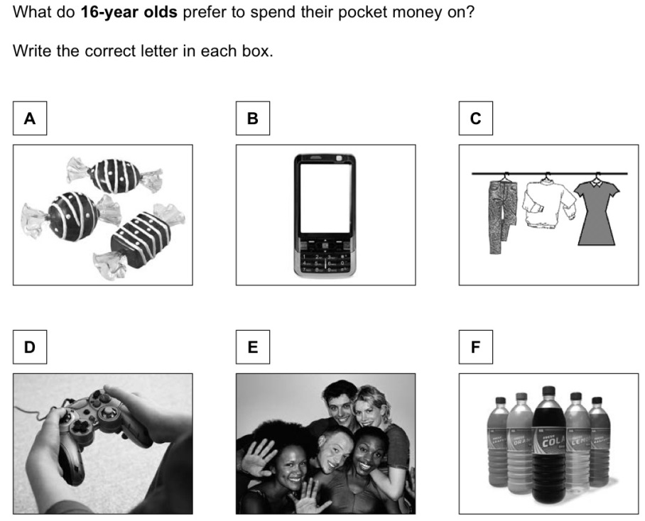

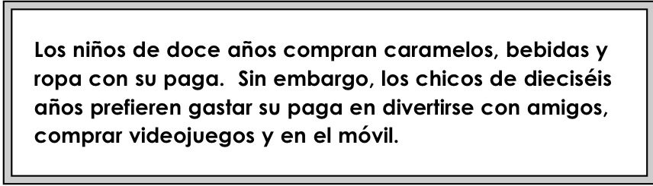

**1 Why is the word 16 year olds highlighted in bold?**

**2 What does the connective Sin embargo tell you?**

**3 What type of word always comes before años?**

**2 Pocket Money**

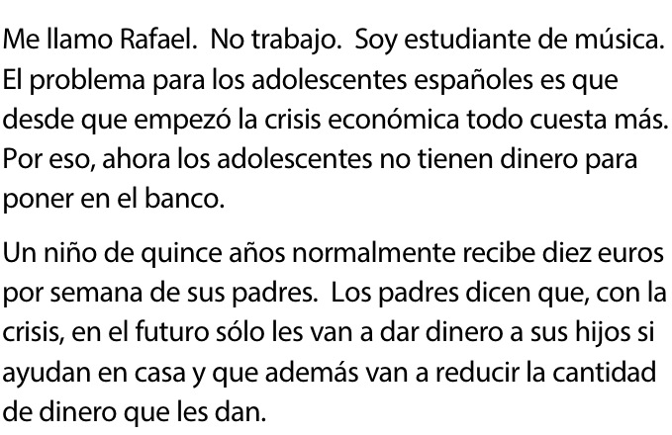

**1 Before answering the question circle all the cognates you recognise!!!!!!**

**2 Look for patterns in the endings of words ie dad = ty word , aw ord ending an r will be a verb.**

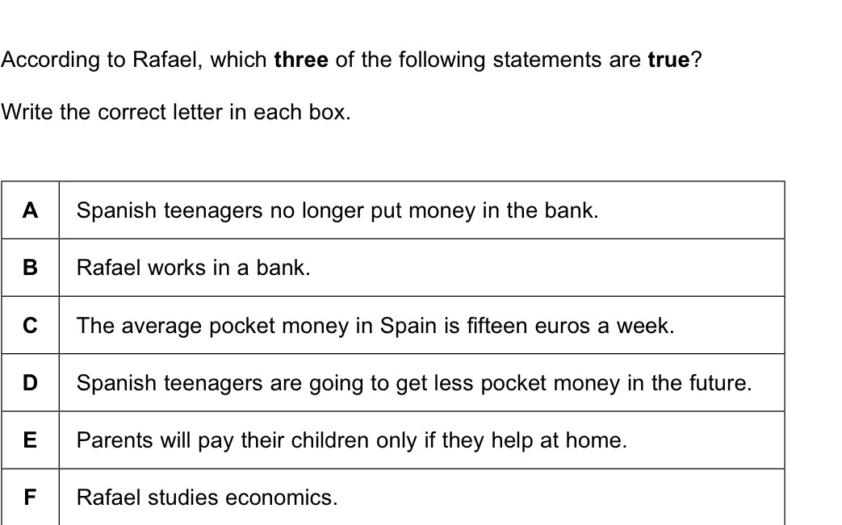

**3 As the text is for three marks divide the text into 3. For A and B look at the first 2 senteces , for the C+D the next two sentences and for E+F.**

**4 From A-F highlight the words you know in Spanish.**

**The answers will be in that order.**

**3 University**

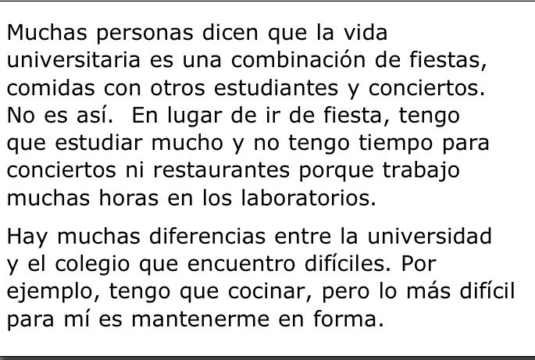

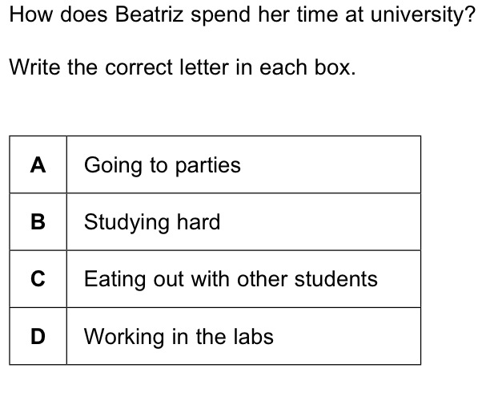

**2 paragraphs = First answer in the first paragraph and the second one in t second.**

**When you have a text past experience shows that the answers are at the end of the sentences. As this is a 2 mark question focus on the last few words of each of the two sentences in t first paragraph.**

**Again circle all the cognates / nouns you recognise**

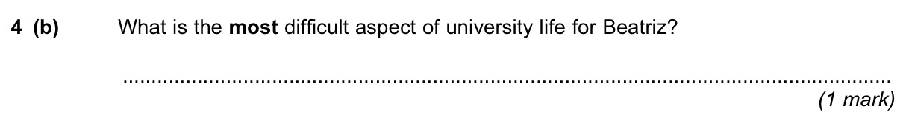

**Again for question 2 look at the end of the sentence.**

**Question 4**

**Opinions on films – this tests your knowledge on adjectives.**

**Watch out for negative phrases used to describe something positive. Remember like Maths 2 negatives = a positive ie No me parece una mala idea. You can see the words no and mala in the same sentence so it is positive.**

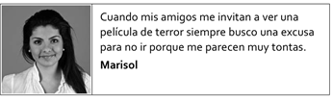

**Again circle the cognates – una excusa? Also adjectives will end in o , a , os , as l , les e , es. Look at the words that have these endings ie tontas?**

**Remember positive and negative answers normally contain a connective like pero but mainly a new sentence with a Capital letter.**

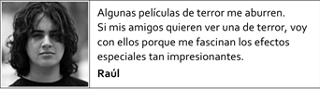

**Same advice as above – are there 2 sentences look at the ending of adjectives – normall come after muy , poco , tan.**

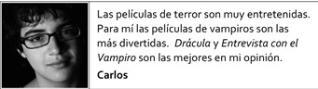

**As above**

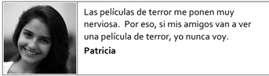

**As above**