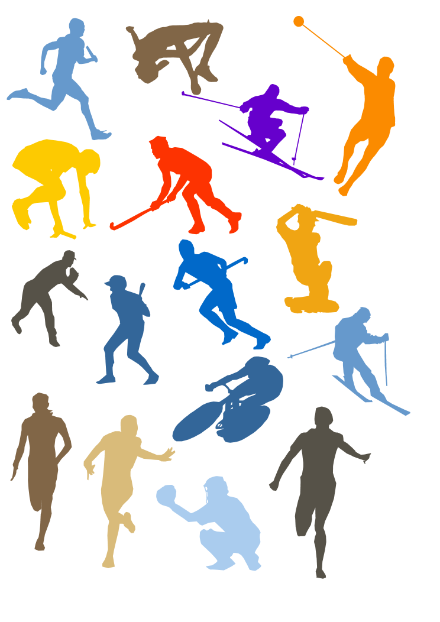

A summary of each topic you have covered whilst completing your GCSE in PE.

*Use in conjunction with other revision methods.*

*This is a revision resource of key points only.*

|  |  |  |  |  |  |  |  |
| --- | --- | --- | --- | --- | --- | --- | --- |
| Topic | | Revised | Understood? | Revised | Understood? | Revised | Understood? |
| 1.1.1  Healthy, active lifestyles and how they could benefit you | The three categories of a healthy, active lifestyle |  |  |  |  |  |  |
| Benefits of taking part in physical activity |  |  |  |  |  |  |
| Reasons for taking part in physical activity |  |  |  |  |  |  |
| 1.1.2  Influences on your healthy, active lifestyle | Influences on taking part |  |  |  |  |  |  |
| Opportunities for getting involved in sport |  |  |  |  |  |  |
| Sports participation pyramid |  |  |  |  |  |  |
| 1.1.3  Exercise and fitness as part of your healthy, active lifestyle | Health, exercise, fitness and performance |  |  |  |  |  |  |
| The five components of health-related exercise |  |  |  |  |  |  |
| The six components of skill-related fitness |  |  |  |  |  |  |
| 1.1.4  Physical activity as part of your healthy, active lifestyle | Assessing your fitness levels |  |  |  |  |  |  |
| The principles of training |  |  |  |  |  |  |
| Goal setting |  |  |  |  |  |  |
| Methods of training |  |  |  |  |  |  |
| The exercise session |  |  |  |  |  |  |
| Comparing two types of training session |  |  |  |  |  |  |
| Analysing training sessions |  |  |  |  |  |  |
| 1.1.5  Your personal health and well-being | The link between exercise, diet, work and rest |  |  |  |  |  |  |
| Dietary intake and performance |  |  |  |  |  |  |
| 1.2.1  Physical activity and your healthy mind and body | Different body types |  |  |  |  |  |  |
| Optimum weight |  |  |  |  |  |  |
| Weight-related conditions |  |  |  |  |  |  |
| Performance-enhancing and recreational drugs |  |  |  |  |  |  |
| Risk assessment and preventing injuries |  |  |  |  |  |  |
| 1.2.2  A healthy, active lifestyle and your cardiovascular system | The cardiovascular system during exercise |  |  |  |  |  |  |
| Regular exercise and the cardiovascular system |  |  |  |  |  |  |
| The effect of lifestyle on the cardiovascular system |  |  |  |  |  |  |
| 1.2.3  A healthy active lifestyle and your respiratory system | The respiratory system |  |  |  |  |  |  |
| Immediate and long-term effects of exercise on the respiratory system |  |  |  |  |  |  |
| 1.2.4  A healthy active lifestyle and your muscular system | The muscular system |  |  |  |  |  |  |
| Exercising the muscular system |  |  |  |  |  |  |
| Lifestyle, performance enhancing drugs and the muscular system |  |  |  |  |  |  |
| 1.2.5  A healthy active lifestyle and your skeletal system | The skeletal system |  |  |  |  |  |  |
| Joints and movement |  |  |  |  |  |  |
| Exercise and the skeletal system |  |  |  |  |  |  |
| Injuries to the skeletal system and the importance of diet |  |  |  |  |  |  |

**1.1.1: Healthy, active lifestyles and how they could benefit you.**

**Health, active lifestyle**: a lifestyle that contributes positively to physical, social and mental wellbeing, and includes regular exercise and physical activity.

**There are 5 REASONS for taking part in physical activity:**

* **Cooperation**

*Teamwork –support and encourage your team work.*

* **Competition**

*Can be regarded as psychological in terms of the mental preparation and in terms of getting away from the stresses of life.*

* **Physical challenge**

*Perhaps someone is coming back to sport after a long time away or taking on a seemingly impossible task. For example The London Marathon.*

* **Aesthetic appreciation**

*Moments in sport are sometimes beautiful. For example a brilliantly executed goal, a cover drive in cricket, a delicate chip in golf or a smash in badminton. Sports such as ice dancing or gymnastics often thought of in these terms.*

* **The development of friendships and social mixing**

*Involvement with others, get to know more people, make new friends and develop lasting friendships. Many sports teams have a strong social side.*

**The BENEFITS for taking part in physical activity fall into 3 categories:**

|  |  |  |
| --- | --- | --- |
| **PHYSICAL** | **SOCIAL** | **MENTAL** |
| Contribute to good physical health | Mix with others | Relieve and/or prevent stress and tension |
| Physical challenge | Make new friends | Mental challenge |
| Increase fitness | Meet current friends | Increase self-esteem and confidence |
| Improve performance | Develop teamwork/cooperation | Help the individual feel good – exercise produces serotonin – a feel-good hormone. |
| Improve health related exercise factors:  Cardiovascular fitness  Muscular strength  Muscular endurance  Flexibility  Body composition | Work with others | Contribute to enjoyment of life |
| Aesthetic appreciation |

**There are 6 INFLUENCES on taking part in physical activity:**

|  |  |  |  |  |  |
| --- | --- | --- | --- | --- | --- |
| **People** | **Image** | **Cultural** | **Resources** | **Health & wellbeing** | **Socio-economic** |
| Family | Fashion | Age | Availability | Illness | Cost (Golf compared to running) |
| Peers | Media Coverage | Disability | Location | Health problems | Status |
| Role models |  | Gender | Access |  |  |
|  |  | Race | Time |  |  |

**1.1.2: Influences on your healthy, active lifestyle.**

people picto.jpg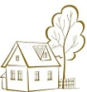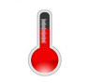

image picto.jpgresources picto.png

|  |  |  |  |
| --- | --- | --- | --- |
| Coaching | Leadership | Volunteering | Officiating |

**Opportunities for getting involved in sport:**

**Initiatives to keep people involved in sport:**

|  |  |  |
| --- | --- | --- |
| **Government Initiatives.**  All pupils  (up to age 16)  have to receive an entitlement of 2 hours of high quality PE per week.  This encourages more participation and improve pupils’ fitness. | **Sport England.**  Sport England believes sport has the power to  change people’s lives.  Sport England creates opportunities for people to ***start, stay and succeed*** in sport.  **Start:** Increase sport participation 🡪 improves health of the nation (focus on priority groups).  **Stay:** Retain people in sport through an effective network of clubs, facilities, volunteers and competition.  **Succeed:** Create opportunities for talented performers to achieve success. | **Active Kids programme.**  Some supermarkets  and enterprises run voucher schemes.  Vouchers are  collected vouchers when people buy items from shops/businesses in return for vouchers. Schools use these vouchers to buy sports equipment. |

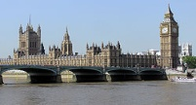

**The Sports Participation Pyramid:**

**The peak of the pyramid – sporting excellence.**

**Pyramid narrows here as less people take part at this level.**

**Governing bodies of sport are responsible for development at this level as athletes pass from county 🡪 regional 🡪 national.**

**Young people begin to develop talent in specific sports.**

**Quality coaching is essential.**

**County and regional level sport.**

**Excellence** eE

**Performance**

**Young people participate in a specific activity for enjoyment but on a regular basis.**

**For example – local football team and extra -curricular clubs.**

**Participation**

**Foundation**

**The base of the pyramid – most participation at this stage. Emphasis on learning/experiencing basic sporting skills e.g. PE lessons.**

**This stage provides a basis for personal development and future participation.**

Exercise improves health and develops fitness, which enhances performance in physical activities.

**1.1.3: Exercsie and fitness as part of your healthy, active lifestyle.**

**Performance:**

How well a task is completed.

**Fitness:**

Ability to meet the demands of the environment.

**Exercise:**

A form of physical activity which maintains or improves health and/or physical fitness.

**Health:**

A state of complete meant, physical and social wellbeing and not merely the absence of disease and infirmity.

It is possible to be fit but not healthy. For example Sir Steve Redgrave, 5 times an Olympic gold medallist for rowing has diabetes and a severe bowel condition.

Coordination

Power

Speed

**Health-Related Exercise.**

*components.*

Body composition

Muscular endurance

Cardiovascular fitness

**Skill-Related Fitness.**

*components.*

Agility

Reaction time

Muscular strength

[http://www.wpclipart.com/signs_symbol/alphabets_numbers/outlined_numbers/white/number_6_white.png](http://www.google.co.uk/url?sa=i&rct=j&q=&esrc=s&frm=1&source=images&cd=&cad=rja&docid=7txrXyIexgNgnM&tbnid=4UUld8HzrNeoFM:&ved=0CAUQjRw&url=http://www.wpclipart.com/signs_symbol/alphabets_numbers/outlined_numbers/white/number_6_white.png.html&ei=gRwNUazXI6er0AWX7oC4Ag&bvm=bv.41867550,d.d2k&psig=AFQjCNGMycnohfRjkNJ4Hi1gkclDYX_dbw&ust=1359900100243438)

|  |  |
| --- | --- |
| **heart.jpgCardiovascular fitness**  *(Marathon and tennis)* | The ability to exercise the entire body for long periods of time |
| **Muscular strength**  *(Weightlifting and rugby scrum)*strength 2.jpg | The amount of force a muscle can exert against a resistance |
| **Muscular**  **endurance**  [http://www.trec-nutrition.co.uk/news/wp-content/uploads/2012/10/classic-push-up_push-up-variations.jpg](http://www.google.co.uk/url?sa=i&rct=j&q=&esrc=s&frm=1&source=images&cd=&cad=rja&docid=PneKsSRjiqYbAM&tbnid=bnx9o-3Trb1SsM:&ved=0CAUQjRw&url=http://www.trec-nutrition.co.uk/news/general/push-ups-101&ei=ZCENUZqkCqOb0QXX1oCICw&bvm=bv.41867550,d.d2k&psig=AFQjCNHvNlIm7UOUbRTvxQmnIpiLJcxRGw&ust=1359901381845078)*(Tennis, running and swimming)* | The ability to use the voluntary muscles many times without getting tired |
| **flex.jpgFlexibility**  *(Gymnastics, high jump, badminton)* | The range of movement at a joint |
| **Body composition**  *(Ectomorph: high jump*  *body comp.gifMesomorph: weight lifting*  *Endomorp: sumo wrestling)* | The percentage of body weight that is fat, muscle and bone |
| **These 5 elements help us to stay physically fit and healthy.** | |

[http://www.wpclipart.com/signs_symbol/alphabets_numbers/outlined_numbers/white/number_5_white.png](http://www.google.co.uk/url?sa=i&rct=j&q=&esrc=s&frm=1&source=images&cd=&cad=rja&docid=9L1FMDN3gzkAwM&tbnid=GUn1un-gX7rN6M:&ved=0CAUQjRw&url=http://www.wpclipart.com/signs_symbol/alphabets_numbers/outlined_numbers/white/number_5_white.png.html&ei=lRkNUa2pEJSM0wXViYD4Cg&bvm=bv.41867550,d.d2k&psig=AFQjCNHVyNjT4oQtT3lt7LAjNpHWRijyiA&ust=1359899327807467)

Balance

Flexibility

|  |  |
| --- | --- |
| **Power**  *(1oom sprint start and triple jump)* | The ability to undertake strength performances quickly.  Power = Strength x Speed |
| **Coordination**  *(Hand-eye: Tennis,*  *Foot-eye: Kicking a ball, Head-eye: football header)* | The ability to use two or more body parts together |
| **Reaction time**  *(100m and badminton)* | The time between the presentation of a stimulus and the onset of movement |
| **Agility**  *(Rugby and badminton)* | The ability to change the position of the body quickly and to control the movement of the whole body |
| **Balance**  *(Static balance: archery*  *Dynamic balance: basketball*  *Static & Dynamic: gymnastics)* | The ability to retain the centre of mass (gravity) of the body above the base of support with reference to static (stationary), dynamic (changing) conditions of movement, shape & orientation |
| **Speed**  *(Leg speed: 100m*  *Hand speed: boxing)* | The differential rate at which an individual is able to perform a movement  or cover a distance in a period of time |
| **P**ower **CRABS** | |
| These 6 elements help people become good at physical activity. | |

**PAR-Q (Physical Activity Readiness Questionnaire).**

A PAR-Q is done prior to starting an exercise programme starting. This makes sure you are safe to exercise.

Considers; Medical conditions e.g. heart condition or asthma, injuries and blood pressure.

**1.1.4: Physical activity as part of your healthy, active lifestyle.**

|  |  |  |  |
| --- | --- | --- | --- |
| **Health related exercise fitness tests** | | **Skill related fitness tests** | |
| **Test name** | **Testing** | **Test name** | **Testing** |
| Cooper’s 12-minute run test | Cardiovascular fitness and muscular endurance in legs. | Illinois agility run | Agility |
| Hand grip strength test | Muscular strength in the hand. | Standing stork test | Balance (static) |
| Sit and reach flexibility test | Flexibility of the hamstrings. | Sergeant jump test | Leg power |
| Harvard step test | Cardiovascular endurance and muscular endurance. | Standing broad jump | Power |
| **It is important to follow the correct protocol for each of these tests. This will ensure results are valid and can be compared.** | | Ruler drop test | Reaction time |
| 30-metre sprint | Speed |
| Three ball juggle | Coordination |

For training to be effective, relevant and safe we must follow set guidelines or principles…

**The principles of training**.

*IS PO FITT…RRR?*

|  |  |  |  |
| --- | --- | --- | --- |
| **I**ndividual needs | | Matching training to the requirements of an individual. | Consider: First time marathon runner compared to an experienced marathon racer compared to a power lifter. |
| **S**pecificity | | Matching training to the requirements of an activity. | To be successful at a particular sport/position you need to develop certain areas of fitness. A goal keeper will train differently to a midfielder. |
| **P**rogressive **O**verload | | Gradually increasing the amount of overload so as to gain fitness without the risk of injury. | Working at an intensity that places demands on the body, but not too much that you cause injury.  Working between 60% and 80% of your maximum HR will make sure you are overloading. |
| **F**requency | **FITT...**  **The ways you can apply Progressive Overload.** | How often you train. | |
| **I**ntensity | How hard you train. | |
| **T**ime | How long is each training session? | |
| **T**ype | Which methods of training are used? | |
| **R**est | | The period of time allotted to recovery. | Adaptation takes place during rest. Rest must be included in a training programme to allow the body time to Recover (repair & adapt) ready for the next session. If not enough rest time is taken, over-training will occur, which could lead to a drop in performance, tiredness, fatigue and therefore:  Reversibility. |
| **Recovery** | | The time required to repair damage to the body caused by training/competition. |
| **Reversibility** | | Any adaptation that takes place as a consequence of training will be reversed when you stop training. | Fitness is lost about 3 times faster than it is gained!  You will experience reversibility if you are; ill, injured, have a lack of motivation, stop or plateau your training. Reversibility will affect people at different rates, depending on how long they have trained for, how fit they are, and how bad the illness or injury is. |

**1.1.4: Physical activity as part of your healthy, active lifestyle.**

**Goal setting.**

**Goal setting.**

By having a goal or aim to achieve, you have a specific focus to work towards.

You can also plan, record and monitor progress easily and accurately, then evaluate and make adaptations to meet your changing needs.

|  |  |  |
| --- | --- | --- |
| **SMART Goals.** | | |
| **Specific**  **[http://www.topendsports.com/sport/archery/images/target-practice.gif](http://www.google.co.uk/url?sa=i&rct=j&q=specific&source=images&cd=&cad=rja&docid=YuGcjs-XoqySVM&tbnid=FPFcLepIg0kg3M:&ved=0CAUQjRw&url=http://www.topendsports.com/psychology/sportspecific.htm&ei=Ns0SUZrwOMKx0AXXpYDgAQ&bvm=bv.41934586,d.d2k&psig=AFQjCNG39QvGOdkmw2MUcvEHDBvWn8a4JQ&ust=1360273074441454)** | Knowing exactly what the goal is. It is specific and relevant to you. | I want to fitter, is not specific.  I want to be able to run 2min 30sec for 800m, is specific. |
| **[http://static.freepik.com/free-photo/color-ruler-vector_34-12821.jpg](http://www.google.co.uk/url?sa=i&rct=j&q=&esrc=s&frm=1&source=images&cd=&cad=rja&docid=QBoTfEF2IrUxpM&tbnid=Tz9Vjxxe_6X4SM:&ved=0CAUQjRw&url=http://www.freepik.com/free-vector/color-ruler-vector_589420.htm&ei=CcsSUYfDGIm1hAeTxYGIBA&bvm=bv.41934586,d.ZG4&psig=AFQjCNFKjrgXj96PyOCN0yZweQ_4c-CvzA&ust=1360272505155704)Measurable** | Easy to know when a goal has been achieved. | Using; reps, sets, times, distances, Kg’s, HR’s, etc. |
| **[http://i.istockimg.com/file_thumbview_approve/3677173/2/stock-illustration-3677173-medal-with-ribbon.jpg](http://www.google.co.uk/url?sa=i&rct=j&q=&esrc=s&frm=1&source=images&cd=&cad=rja&docid=SkQCzNKnk9QI-M&tbnid=L41_IaKEomlRQM:&ved=0CAUQjRw&url=http://www.istockphoto.com/stock-illustration-3677173-medal-with-ribbon.php&ei=z8sSUeflKYWXhQeiyIGgDg&bvm=bv.41934586,d.ZG4&psig=AFQjCNHxvwPfix6RG9HNKqGmbfnkuuI8Uw&ust=1360272646490518)Achievable** | If you believe something can be achieved you stay motivated, as you see results. results. | Aiming to complete a marathon with no previous long distance running experience in 2 weeks is not achievable! Aiming to run a 2min 30sec 800m in 6 weeks might be achievable. |
| **[http://www.deviantart.com/download/261946101/question_makrs_cutie_mark_by_rildraw-d4byewl.png](http://www.google.co.uk/url?sa=i&rct=j&q=&esrc=s&frm=1&source=images&cd=&cad=rja&docid=GZnpTqeZDWVbKM&tbnid=fmGCxDmz6agtvM:&ved=0CAUQjRw&url=http://the-smiling-pony.deviantart.com/art/Question-marks-cutie-mark-261946101&ei=tsoSUcq1PIfKhAe4lAE&bvm=bv.41934586,d.ZG4&psig=AFQjCNHvIvZGivD52lVkymIi2J8k-zaJNw&ust=1360272431538591)Realistic** | A goal needs to be achievable in practice as well as theory. | A 2min 30sec 800m will depend on; current performance and amount of time that can be dedicated to the training. |
| **[http://www.politicsint-blog.co.uk/wp-content/uploads/2011/01/object_alarm_clock001.gif](http://www.google.co.uk/url?sa=i&rct=j&q=alarm+clock&source=images&cd=&cad=rja&docid=HvzO_XB1OK-Z2M&tbnid=So_zZ9LH6wiBJM:&ved=0CAUQjRw&url=http://www.politicsint-blog.co.uk/the-wide-awake-club/&ei=0M0SUeWUD4Gc0QXC6oCIDA&bvm=bv.41934586,d.d2k&psig=AFQjCNGcb_ardEWDatwpucUB--c2wsTplQ&ust=1360273211428002)Time-bound** | Does the goal have an end point? | If not, then reaching it can be delayed or put off. Knowing you have 6 weeks until a race, you are likely to be motivated to make the improvements necessary. |

**Past exam question (June 2012)**

**(long answer question)**

**12**. Eshan is inspired by performers in the run up to the London 2012 Olympic and Paralympic Games, and is determined to improve his performance. He decides to set SMART targets as a first step to achieving his long-term goal.

Discuss the use of target setting to improve performance.

You must make reference to examples in your answer. (6 marks)

[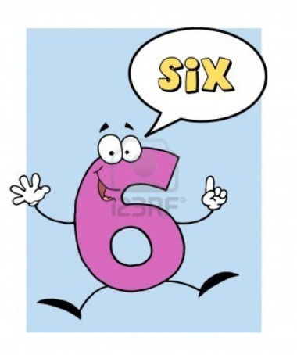](http://www.google.co.uk/url?sa=i&rct=j&q=&esrc=s&frm=1&source=images&cd=&cad=rja&docid=kqaFWgHHkPOHyM&tbnid=tesJ1-NaX5MB9M:&ved=0CAUQjRw&url=http://www.123rf.com/photo_8284405_number-6-six-guy-with-speech-bubble.html&ei=29ISUcL3GYfL0AXwy4G4Cg&psig=AFQjCNGzUpIyioayK-CJ1CewIMVZqpaoqg&ust=1360274396891241)

**Methods of training.**

There are 6 different training methods:

|  |  |  |  |  |  |
| --- | --- | --- | --- | --- | --- |
| **Circuit** | **Continuous** | **Interval** | **Fartlek** | **Weight** | **Cross** |

**1.1.4: Physical activity as part of your healthy, active lifestyle.**

**Methods of training.**

**Methods of training: Circuit Training.**

|  |  |
| --- | --- |
| **ADVANTAGES** | **DISADVANTAGES** |
| Easy to set up and is flexible | Can require lots of equipment depending on the type of circuit. |
| Can select activities **specific** for your sport | Have to keep checking a stopwatch if you have no training partner. |
| Adaptable to team games and individual fitness levels | Can be difficult to maintain work rate. |
| Can develop both fitness and skills | http://www.muscle-fitness-tips.net/image-files/circuit-training.jpg |
| Allows a rest period in between stations for recovery. (Intervals) |
| Develops both aerobic and anaerobic systems |
| Can be set up to develop all areas of HRE & SRF. |
| Easy to apply Progressive Overload and measure improvement. |

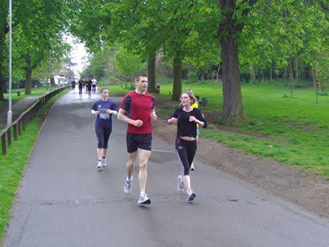

**Methods of training: Interval Training**

|  |  |
| --- | --- |
| **ADVANTAGES** | **DISADVANTAGES** |
| Takes place over short periods of time. | Can become repetitive and requires motivation to continue. |
| Includes rest which allows recovery. | Difficult to identify how hard an individual is working. |
| Includes repetitions which raises the HR to near maximal | Can be difficult to maintain work rate. |
| Develops aerobic and anaerobic systems. | http://www.total-soccer-fitness.com/image-files/progressive_shuttles.jpg |
| Can develop other areas of fitness and skill – agility,  speed etc. |
| Allows for monitoring and evaluating of HR. |

**Methods of training: Continuous Training**

|  |  |
| --- | --- |
| **ADVANTAGES** | **DISADVANTAGES** |
| You can work on your own or in a group. | Can become boring and requires motivation to continue. |
| Improves Aerobic fitness. | Time consuming. |
| Can take place in a variety of venues. | Does not develop other  components of fitness –  e.g. strength, agility. |
| It can be adapted to suit your individual needs |
| Very cheap! Minimal equipment. |
| Easy to monitor and apply Progressive Overload. |

**Methods of training: Fartlek Training.**

|  |  |
| --- | --- |
| **ADVANTAGES** | **DISADVANTAGES** |
| Takes place over short periods of time. | Can become repetitive and requires motivation to continue. |
| Includes active rest which allows recovery. | Difficult to identify how hard an individual is working. |
| Includes repetitions which raises the HR to near  Maximal**.** | Can be difficult to maintain work rate |
| Develops aerobic and anaerobic systems. | **FARTLEK AND INTERVAL TRAINING ARE VERY SIMILAR…FARTLEK TRAINING HOWEVER CAN TAKE PLACE OVER DIFFERENT TERRAINS AND CAN INCLUDE HILLS.** |
| Can develop other areas of fitness and skill – agility, speed etc. |
| Adaptable to team games and individual fitness levels |
| Can be done almost anywhere on any terrain. |
| 1. Takes place over short periods of time |

**Methods of training: Weight Training.**

|  |  |
| --- | --- |
| **ADVANTAGES** | **DISADVANTAGES** |
| Can improve Muscular Strength, Muscular Endurance and Power (Strength x Speed). | Requires specialist equipment, which can be expensive. |
| Increase Muscle size or bulk. | Requires knowledge of correct techniques to gain benefits and avoid injury. |
| Improve muscle tone. | http://t1.gstatic.com/images?q=tbn:ANd9GcR907uZs5tAKRtIMEmw7ANlNmNQZ71xDUhzFezWUHapQtzwyPnQR9FUkrKV |
| Assist recovery after injury, rehabilitation. |
| Can focus on specific areas/muscles in the body. |
| Large variety of exercises. |
| Easy to monitor and apply Progressive Overload. |

**Methods of training: Cross Training.**

Remember cross training is a combination of training methods, not activities. It does not mean going swimming one day, playing football the next, and badminton the next.

|  |
| --- |
| **ADVANTAGES** |
| Allows for a variety of training and therefore can make training interesting. |
| You can train with different people in different activities, or you can train alone. |
| Certain muscle groups can be rested from day-to-day. |
| Training can be adapted to suit the weather conditions. |

**Sporting examples:**

* Sprinters require speed, so they may use interval training; power and strength, so they use weight training; and possibly other methods such as circuit training.
* Racket players need speed, so they could use interval training and circuit training for muscular endurance.

**1.1.4: Physical activity as part of your healthy, active lifestyle continued.**

**The exercise session.**

|  |  |  |
| --- | --- | --- |
| **The warm up gradually raises the body temperature, heart rate and improves the exchange of oxygen from haemoglobin.** | | |
| **The warm up.** | | |
| Start with a **Pulse raiser** | Followed by...**Stretching** | Finish with **Specific skills practice**. |
| * Cardiovascular warm-up to raise heart rate to working heart rate. * Cycling, jogging, skipping etc. * Usually takes between 5-15 mins * Also allows for mental preparation. * Could use music for motivation. | * Static: hold for 10-15 seconds. * Dynamic (ballistic): bouncing/active stretching. * Generally start at top of body. * Pay attention to areas used in sport – e.g. neck and shoulders in rugby. | * Needs to be specific to the activity. * Tennis players may practice specific shots. * Cricketers may practice catching, batting and bowling. * Sprinters may practice their starts. |
| **The main activity or event.** | | |
| * Raises performer’s heart rate above normal level for approx 20 minutes. * Could be continuous training for a long distance runner or a skill circuit for a hockey player. * Could include a game or be a competition. * Focus of the session may be to focus on rehabilitation following an injury. * Consider timing – pre-season or just before a major competition? * What component of fitness is aimed at being improved? Cardiovascular fitness, muscular strength or flexibility perhaps? * Skill focus – this could be done through a circuit | | |
| The cool-down. | | |
| * Returns body to normal resting heart rate. * Important to include after every training session/competitive situation – most important after an anaerobic work-out. * Disperses lactic acid therefore helps to prevent stiffness and soreness in muscles. * Jogging can be used. * Takes approximately 5-10 minutes for heart rate to return to resting. * Stretching incorporated – static stretches held for about 30-35 seconds. * Relaxation exercises should finish the session – especially if session has been high intensity. | | |

Comparing two types of training session: Aerobic and anaerobic fitness.

**1.1.4: Physical activity as part of your healthy, active lifestyle continued.**

|  |  |
| --- | --- |
| **Aerobic = with air**   * Lower intensity than anaerobic, and performers would breath throughout it. * Means can exercise for longer periods of time than anaerobic than anaerobic. * Marathon=aerobic event. | **Anaerobic = without air**   * Out of breath after the exercise as body has been working at a high intensity. * Also out of breath as the body, which requires extra oxygen when working, has not had enough oxygen during the exercise. * 100m = anaerobic event. |
| **Aerobic:** ‘with oxygen’. If exercise is not too fast and is steady, the heart can supply all the oxygen muscles need. | **Anaerobic:** ‘without oxygen’. If exercise is done in short, fast bursts, the heart cannot supply blood and oxygen to muscles as fast as the cells use them. |
| **For this section of the specification, you will need to:**   * **Understand and explain how a method of training can be used to create different effects and improve physical performance.** * **Understand how different methods of training can match individual needs and differences.** * **Use the principle of specificity.** | |

**1.1.4: Physical activity as part of your healthy, active lifestyle continued.**

**Analysing training sessions.**

Analysing training sessions is essential to monitoring ability and improvements. Without analysis it would be impossible to know whether training sessions were effective.

|  |  |  |  |
| --- | --- | --- | --- |
| **Heart Rate**  *[http://www.azumio.com/wp-content/uploads/2012/12/heart_rate_by_shorty6636-d33l3us1.jpeg](http://www.google.co.uk/url?sa=i&rct=j&q=&esrc=s&frm=1&source=images&cd=&cad=rja&docid=6mGy7ilPiPD4MM&tbnid=A6sdmOno49QVDM:&ved=0CAUQjRw&url=http://www.azumio.com/low-heart-rate/&ei=U7caUavSEMO20QWM7ICADg&bvm=bv.42261806,d.d2k&psig=AFQjCNGjOZ-52koKxP7457RYhJ7RFuL0ZA&ust=1360791760525444)The number of times the heart beats per minute (bpm).* | **Resting Heart Rate**  *Your HR at rest. Normally between 60-80bpm. The fitter you are the lower your RHR will be – your heart is more efficient at pumping the same amount of blood around the body with fewer beats. Best taken just as you wake up.* | **Working Heart Rate**  *HR during/immediately after exercise. This is an accurate guide to the Intensity (FITT) of the exercise.* | **Recovery Rate**  *How long it takes for a person’s HR to return to its RHR after training. The quicker this happens, the fitter the person is.* |
| **Maximum Heart rate**  *Calculated according to a person’s age.*  *220-age=maximum heart rate (BPM).* | | | |

Work out Maximum Heart Rate (MHR)

220-age = MHR (bpm).

Work out 60% of your MHR = Lower Threshold.

Work out 80% of your MHR =Upper Threshold.

This is your aerobic Target Zone – 60-80% of MHR.

This is your anaerobic Target Zone – above 80%

|  |  |
| --- | --- |
| Aerobic threshold = 60-80% of MHR  Anaerobic threshold = 80%+ of MHR  So ...  If you are 15 years old:  MHR = 220-15 = 205bpm  60% of 205 = 123bpm  80% of 205 = 164bpm  Therefore, your aerobic threshold = 123(*lower threshold*)-164(*upper threshold*) bpm and  Your anaerobic threshold = 164-205 bpm | If you works above 60% of your MHR:   * Fat will be burned – body composition. * Increased levels of fitness.   If you work just below your anaerobic threshold – your upper aerobic threshold:   * The athlete will build up their lactic acid tolerance. Therefore, the athlete will be able to work for longer without fatiguing. |

The link between exercise, diet, work and rest:

Can provide finance, motivation and opportunities.

Exercise

Diet

Work

Rest

Happiness and Wellbeing

Maintains a balance between work and exercise.

A balanced diet provides the nutrients for health, fitness, strength and wellbeing.

Benchmark level of fitness to enjoy work and life.

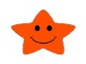

Happiness and wellbeing

Rest

Work

Diet

Exercise

**1.1.5: Your personal health and wellbeing.**

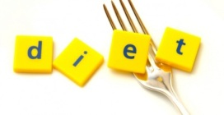

**Diet:** The normal food we eat.

**A balanced diet:** A diet which contains an optimal ratio of nutrients.

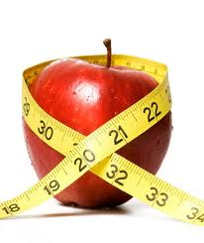

**Special diets:**

Special diets exist such as vegan, vegetarian and gluten free. *Special diets may be adopted to:*

*🡪* Control body composition or body weight.

🡪 Comply with moral or religious reasons.

🡪 Due to allergies such as gluten in wheat & dairy products.

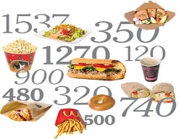

Diet is an essential part of providing the **energy** needed to work and exercise,

and also to **rest and repair** tissue.

The **energy balance** must be considered: **calories in should equal calories used**.

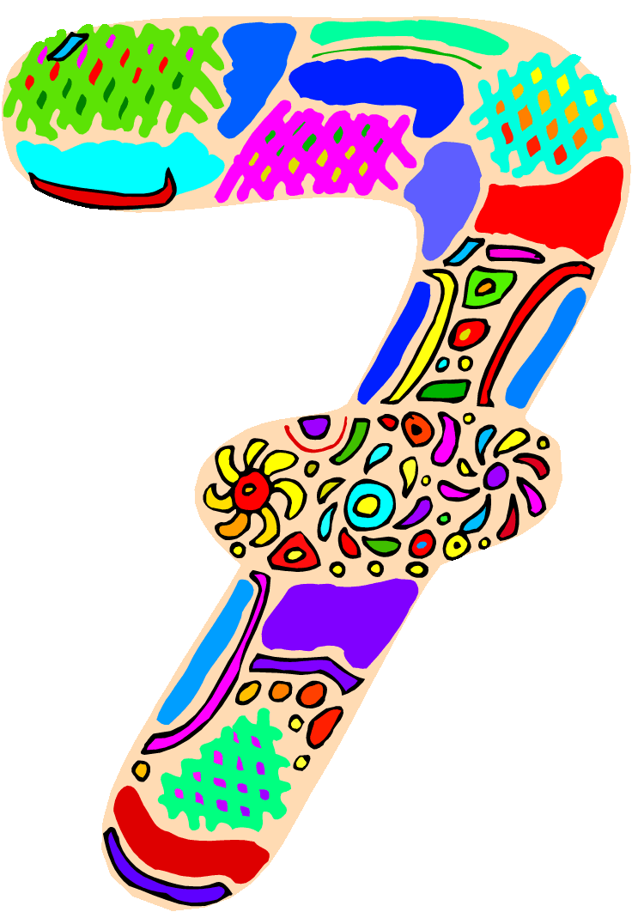

**A balanced diet is made up of 7 components.**

|  |  |  |  |  |  |  |  |
| --- | --- | --- | --- | --- | --- | --- | --- |
|  | **Macro Nutrients** | | | **Micro Nutrients** | |  |  |
| **Carbohydrates**  *http://www.walldesk.net/pdp/1024/02/0/Pasta-Curls,-Venice,-Italy.jpg(complex and simple)* | http://www.weightlossforall.com/wp-content/uploads/2010/08/shutterstock_76758124-300x267.jpgProtein | Fats  http://images.idiva.com/media/photogallery/2012/Sep/oliveoil_600x450.jpg | *http://breastfeedingarts.files.wordpress.com/2011/10/milk.gif*Minerals  *(calcium and Iron* | http://www.jerusalembaskets.com/uploads/cut_fruits_theme_image.jpgVitamins | http://nutritiousndelicious.com/blog/wp-content/uploads/2011/04/oats.jpgFibre | http://images.wisegeek.com/water-glass.jpgWater |
| **Function** | Slow release longer lasting energy.  Simple: sugars  Complex: starch. | Build muscle and repair injuries to muscle. | Provide energy, glycogen stored in muscles. | Strong bones withstand the impact of exercise and everyday life. | Vision, skin, red blood cell formation, healing, blood clotting. | Aids digestive system. | Transports nutrients (hormones) |
| **In sport** | Ready source of energy for muscles.  Long distance events-marathon. | Builds muscle and repairs tissue. Essential after an injury for quick healing. Body builders take in extra protein to bulk muscles. | Increase size & weight of body🡪extra bulk. Stored as energy, used when carbohydrate &protein stores are depleted. | Increase efficiency of o2 to working muscles. Iron helps produce red blood cells – more o2 can be carried🡪prevents fatigue. | Overall good health – important for optimum performance. When training hard B group vitamins used more so need replenishing. | Less cholesterol🡪efficient heart. Keeps digestive system functioning regularly. | Prevents dehydration and heatstroke – sweating. Allows blood to flow easily around body. |

[](http://www.google.co.uk/url?sa=i&rct=j&q=&esrc=s&frm=1&source=images&cd=&cad=rja&docid=aA3Rx280nJhLZM&tbnid=sCcFDZUS0PXxzM:&ved=0CAUQjRw&url=http://grocerytrader.co.uk/?p=1379&ei=QKcjUYH8O4Kq0QW6_YDYBQ&bvm=bv.42553238,d.d2k&psig=AFQjCNHWlTdg96MVy8dKtwEYtkJQcCJBeA&ust=1361377465151548)

**Macro Nutrient: Carbohydrates.**

* Provide energy.
* Stored in muscles and as glycogen in the liver. Glycogen is quickly converted to glucose 🡪 energy.
* Two types: complex and simple.

|  |  |
| --- | --- |
| **Complex – Starchy foods** | **Simple - Sugars** |
| Bananas, wholemeal bread, potatoes. Found in natural foods. | Natural sugars found in fruit and vegetables. |
| Slower and longer lasting release of energy than simple carbohydrates. | Refined sugars found in biscuits and cakes. |
| Contribute to good long-term health |  |
| Should form approx 50% of daily intake. |
| Aid to the sportsperson ...   * Ready source of energy for muscles. * Simple carbohydrates provide sugar but no other nutrients, therefore better to eat more starches. * Excess carbohydrates stored as glycogen and, on demand, release energy slowly. Long distance events can take advantage of this. | |

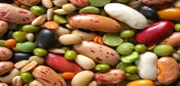

**Macro Nutrient: Protein.**

* Important to build muscle and repair damaged tissue.
* Provides energy during extended periods of exercise (e.g. a marathon) when carbohydrate supplies are depleted.
* Protein comes from two types of food: 2/3 in animal protein. 1/3 in plant or vegetable protein.

|  |  |  |  |  |  |  |  |
| --- | --- | --- | --- | --- | --- | --- | --- |
| **Animal Protein** | | | | **Plant/vegetable Protein** | | | |
| Meat | Poultry | Fish | Dairy products | Pulses | Lentils | Peas | Beans |
| Aid to the sportsperson...   * Builds muscle and repairs tissue. * Essential after an injury to heal quickly. * Athletes who need large muscle size will take in extra proteins for this effect. | | | | | | | |

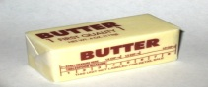

**Macro Nutrient: Fats.**

* Provide energy and, together with glycogen, help muscles to work.
* They can be found in butter, margarine and cooking oils. They can also be found in foods such as bacon, cheese, oily fish and nuts.
* Should form about 30% of our daily intake.

|  |
| --- |
| Aid to the sportsperson...   * Increase size and weight of body. * Important for performers who benefit from having extra bulk, shot putters for example. * Unnecessary weight can inhibit performance and lead to high cholesterol levels. * Fats are stored as energy and released slowly when depletion of carbohydrate and protein stores. |

http://www.health32.com/wp-content/uploads/2010/09/anemia.jpg

**Micro Nutrient: Minerals.**

|  |  |  |  |
| --- | --- | --- | --- |
| **Calcium** | **Iron** | **Sodium** | **Potassium** |
| * Vital for health * Essential in childhood and adolescence * Teeth and Bones (makes them strong). * Reduces likelihood of osteoporosis. | * Essential for blood and it aids oxygen carrying capacity * Helps form red blood cells * Lack of iron can cause anaemia and tiredness. * Meat = good source of iron. | * Regulates body water content. * Aids nerve functioning. | * Important to the functioning of cells. |
| Aid to the sportsperson....   * Increases efficiency of carrying O2 to working muscles. * Iron helps produce red blood cells and so more O2 can be carried around the body – prevents fatigue. * Calcium helps blood to clot aiding recovery from injury, and strengthens bones and muscles. | | | |

[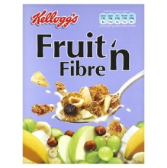](http://www.google.co.uk/url?sa=i&rct=j&q=&esrc=s&frm=1&source=images&cd=&cad=rja&docid=CBZJ3fcPLVCalM&tbnid=hUAY3wTrLHm0DM:&ved=0CAUQjRw&url=http://www.ocado.com/webshop/product/Kelloggs-Fruit-n-Fibre/10021011&ei=QLwjUbfzDMeb0QXu24HQBA&bvm=bv.42553238,d.d2k&psig=AFQjCNE6sleflqgafd8CzkDJLIEcC7M1qw&ust=1361382842750792)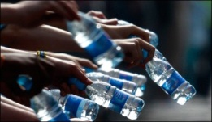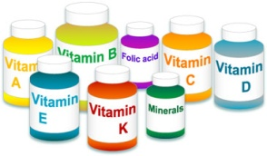

**Water.**

* Water accounts for around half of body weight
* Water: holds oxygen, transports nutrients, waste and hormones.
* Water controls the distribution of electrolytes (body salts).
* Water is essential to control body temperature…especially when exercising
* 8 glasses a day!

|  |
| --- |
| Aid to the sportsperson...   * Allows blood to flow more easily around body – important when exercising as body demands more O2, nutrients, heat control and waste removal. * Water is lost through perspiration🡪 dehydration and heatstroke if not replenished. * Excess water can be fatal so care to be taken. |

**Fibre.**

* Adds bulk to food
* Aids the functioning of the digestive system.
* Fibre (roughage) found in the leaves, stems and fruits of plants.
* There are 2 types of fibre: Soluble and insoluble. A balanced diet should include both.
* Without fibre our bodies would not be able to get rid of waste products, which would lead to many diseases.

|  |  |
| --- | --- |
| **Insoluble Fibre** | **Soluble Fibre** |
| Required as a bulking agent to prevent constipation. | Reduce blood cholesterol levels. |
| * Wholegrain cereal * Wholegrain bread | * Oats * Fruit * Vegetables |
| Aid to the sportsperson...   * Less cholesterol in body makes heart more efficient, important for transporting blood to muscles. * Keeping digestive system functioning regularly retains less waste. | |

Micro Nutrients: Vitamins.

Vitamins are necessary for:

* Good vision
* Good Skin
* Red Blood Cell Formation
* Healing
* Healthy Bones & Teeth
* Blood Clotting
* Vitamins come in 2 groups; water soluble (B and C) and fat soluble (A, D and E).

|  |  |  |  |  |
| --- | --- | --- | --- | --- |
| **Vitamin A** | **Vitamin B1** | **Vitamin C** | **Vitamin D** | **Vitamin E** |
| Milk, cheese, liver and carrots. | Whole-grains, nuts and meats. | Fruits and vegetables. | Fish. | Vegetable oil, wholemeal bread and cereals. |
| Aids vision. | Release carbohydrates. | Healing and fighting infection. Maintenance of bones, teeth and gums. | Healthy bones. | Growth and development. |
| Aid to the sportsperson...   * Overall general health – important for optimum performance. * When training hard, vitamins from the B group are used more and so need to be replenished – therefore supplements may be used. | | | | |

It is not only important to consider **WHAT** to eat for optimal performance, but also **WHEN**.

**1.1.5: Your personal health and wellbeing continued.**

**Dietary intake and performance.**

**Carbo-loading.**

* Frequently used by marathon runners and ultra-distance athletes for examples triathletes.
* Makes maximum use of an athlete’s energy resources.

**High-protein diets.**

* Can allow for loss of weight over fairly short period of time (2 weeks).
* Used for rehabilitation after an injury.
* Burn fat and increase muscle mass – taking creatine (protein supplement) will aid this.

Possible side effects:

* Too much animal protein raises cholesterol levels 🡪 heart disease, strokes, diabetes and cancer.
* Can cause kidney damage in the long term.

**Blood shunting.**

At the beginning of exercise blood is sent to the working muscle.

🡪Therefore, less food is available to digest food in the gut 🡪 this may cause cramps and stomach discomfort.

This flow if blood from other areas into the muscle is known as bloody shunting..

🡪Therefore, it is recommended that exercise should not start until at least 2-3 hours after the last meal.

**1.2.1: Physical activity and your healthy mind and body.**

**Different body types.**

|  |  |  |
| --- | --- | --- |
| **Endomorph** | **Mesomorph** | **Ectomorph** |
|  |  |  |
| = Fatness   * Wide hips, narrow shoulders | = Muscularity   * Wide shoulders, narrow hips | = Linearity / thinness   * Narrow shoulders & hips |
| Forwards in Rugby and sumo wrestlers. | Shot putters and 100m runners. | Marathon Runners |
| More fat = more weight behind actions. | Stronger and suited to more anaerobic events. | Less weight to carry = can work for longer. |

|  |  |
| --- | --- |
| Somatotype | classification of body type |
| Endomorph | An individual with wide hips and narrow shoulder, characterised by fatness. |
| Mesomorph | An individual with wide shoulders and narrow hips, characterised by muscularity |
| Ectomorph | An individual with narrow shoulders and narrow hips, characterised by thinness |

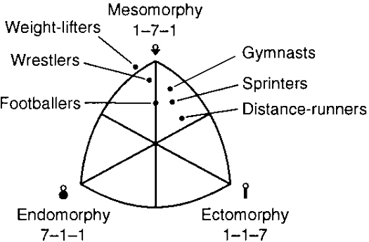

**How to identify your somatotype.**

* Fatness, muscularity and linearity/thinness and height in relation to weight are measured and graded out of 7.
* Once you have all of these measurements you can then plot it on a somato chart.

**Optimum weight.**

* Dictionary definition for optimum = ‘most favourable’ or ‘best compromise’.
* It may relate to an individual’s general lifestyle or their specific sport.
* Sports people will get to know their optimum weight and aim to stay as close to it as possible.
* Optimum weight can be found using the BMI index or by measuring wrist girth.

**1.2.1: Physical activity and your healthy mind and body.**

**Optimum weight.**

**Factors affecting optimum weight:**

* **Height** – taller people are generally, although not always, heavier than shorter people.
* **Gender** – male have more muscle and larger bones therefore different optimum weight charts must be used for males and females.
* **Bone Structure** – all individuals have different structures or frame sizes. Two athletes may be the same height but have different structures and therefore not have the same optimum weight.
* **Muscle girth** – individuals will have different muscle girths and therefore weigh more, therefore height: weight ratio charts may give overweight readings.
* **Genetics** – body weight and shape are largely passed through genes from parents to child.

**Optimum weight in sport.**

* This will vary according to the sport and position within the sport.
* A rugby forward needs strength and power, therefore they would have a higher optimum weight than someone of the same height.
* Jockeys are short in height, have a slight bone structure and little muscle = lower weight allows the horse to move faster.

**Losing weight.**

* Some sports require athletes to lose weight quickly, possibly rapidly to meet weight demands.
* People who want to lose weight will:

🡪Decrease their calorie intake = diet

🡪Increase their calorie expenditure = exercise

🡪Or do both (dieting plus exercise).

[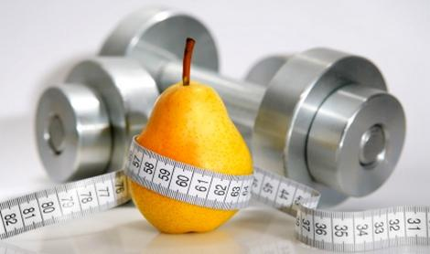](http://www.google.co.uk/url?sa=i&rct=j&q=&esrc=s&frm=1&source=images&cd=&cad=rja&docid=kd78pXNPloWJsM&tbnid=HUBDRo5Fm_hKuM:&ved=0CAUQjRw&url=http://www.medimanage.com/my-weight/articles/basic-weight-losing-tricks-you-can-start-now.aspx&ei=VtYjUY3hOPPa0QWWzIGIBA&bvm=bv.42553238,d.d2k&psig=AFQjCNHhNknDuWhW3Hkl59cL4WmlyPuRNg&ust=1361389521560688)

**Past exam question (June 2010)**

7. Despite their difference in size the performers below are at the **optimum weight** for their activity.

(a) Explain the term **optimum weight**.

..............................................................................................................................................................................................................................................................................................................................................................................................................**(2)**

(b) Optimum weight will be different for different individuals even if they are competing in the same event. State **two** factors that will cause optimum weight to vary.

..............................................................................................................................................................................................................................................................................................................................................................................................................**(2)**

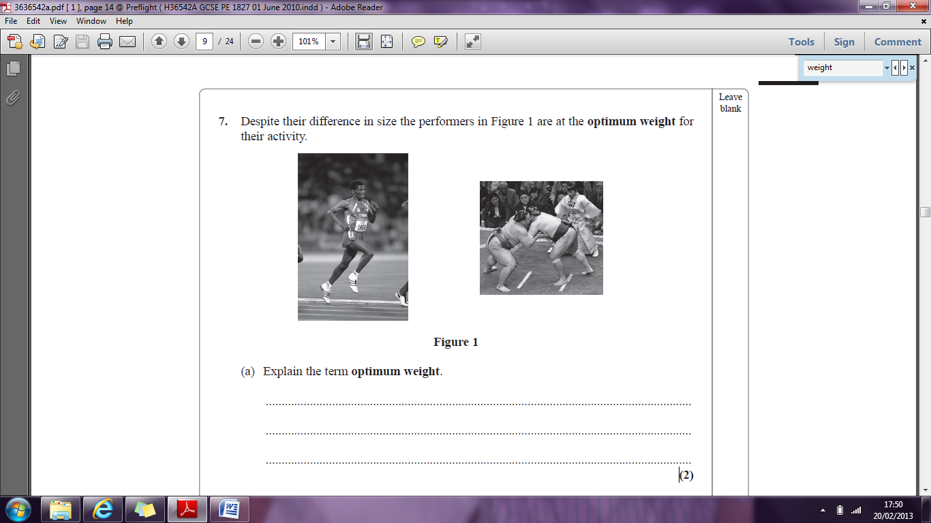

**7a** 1.Being at the right/best weight/not being too heavy/equivalent 2. Based on your stature/equivalent 3. For the activities they are involved in/long distance runner lighter than sumo wrestler/equiv *1 mark from each row (1, 2 or 3*). **7b** Sex, height, bone structure, muscle size/girth.

**1.2.1: Physical activity and your healthy mind and body.**

**Weight-related conditions.**

|  |  |  |  |  |
| --- | --- | --- | --- | --- |
| **Anorexic** | **Obese** | **Overfat** | **Overweight** | **Underweight** |
| Pertaining to anorexia – a prolonged eating disorder due to the loss of appetite. | Used to describe people who are very overfat. | Having body fat in excess of normal. | Having weight in excess of normal (not harmless unless accompanied by overfatness). | Weighing less than normal, healthy or required. |
| * Can lead to extreme weight loss and result in a serious lack of nutrition as well as psychological problems related to obsessions with food and calories. | * Leads to risks of cancer, heart disease leading to heart attacks and strokes, high blood pressure and diabetes. * Extra weight makes exercise difficult/uncomfortable = this makes the individuals less motivated and less likely to participate in sport/physical activity. | * Describes a physique of excessive fat content and can be used to classify someone who is overweight. * E.g. a woman who is overweight and has a high fat content = overfat. * A female weightlifter may be overweight according to BMI but not be overfat. | * May be caused by medical reasons but more frequently associated with overeating or lack of activity. * Can refer to someone whose body weight is greater than normal due to greater muscle mass or bone structure. * Can be beneficial in sports as it can mean more muscle = more strength. * E.g. javelin throwers, rugby players. | * Some sports require weight categories/limits * E.g. boxing – losing weight can be blamed for poor performance * Flat race jockeys are deliberately underweight. * How the weight is lost can impact on performance. * Weight can be lost through sweat – exercising, sweat suits, steam baths etc. * Weight can also be lost through drugs – diuretics increase urine production which can lead to dehydration. |

**Past exam question (June 2009)**

1(h) Which of the following is the correct definition of the term overweight?

**A** having weight in excess of normal

**B** having weight that makes you obese

**C** being overfat

**D** weighing 6 stone more than you should. (1)

**Past exam question (June 2010)**

2c Why could the following statement be considered false?

‘Losing weight makes you look better, therefore feel better.’

..............................................................................................................................................................................................................................................................................................................................................................................................................**(2)**

**1h** A, **2c** 1 mark for correct focus – i.e. problem is with looking better, 2nd mark for explanation – i.e. losing weight does not necessarily make people look better/ could lead to being underweight - look worse/ weight should considered in terms of being healthy not how the individual looks.

**There are two main categories of drugs:**

1. Performance-enhancing

2. Recreational

**A drug is a substance that can be taken in a variety of ways to produce expected and welcome physical and/or psychological effects on the person taking it, but may cause some effects that are both unpleasant and unwanted (side effects).**

**1.2.1: Physical activity and your healthy mind and body.**

**Performance-enhancing and recreational drugs.**

[](http://www.google.co.uk/url?sa=i&rct=j&q=&esrc=s&frm=1&source=images&cd=&docid=eYcG8cpzkYkljM&tbnid=tSASYd5tUOgoxM:&ved=0CAUQjRw&url=http://lizkingevents.com/2013/02/04/2-things-to-consider-when-trying-a-new-event-tech-product/&ei=_tojUfXpLtK20QXlv4CYCg&bvm=bv.42553238,d.d2k&psig=AFQjCNG64DxyQhdjV6KfTiWx1f1OHQHclA&ust=1361390707709542)

**Possible side effects:**

* They may be addictive (nicotine – cigarettes, alcohol, heroin and cocaine).
* Physical side effects can range from high blood pressure to insomnia.

**Performance-enhancing drugs.**

Possible side effects:

* Increased risk of heart attacks and strokes
* High blood pressure
* Liver disease
* Increased risk of muscle injury
* Infertility in women
* Worst case scenario – death.
* E.G. Dwain Chambers, 100m sprinter
* Drugs that mimic the male sex hormone testosterone and promote bone and muscle growth.
* Increases muscle mass and develops bone growth, therefore increasing strength whilst also allowing the athlete to train harder and quicker.
* Can increase aggression.
* Produces results quickly.

**Anabolic steroids**

[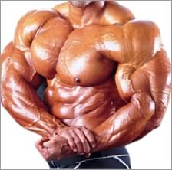](http://www.google.co.uk/url?sa=i&rct=j&q=&esrc=s&frm=1&source=images&cd=&cad=rja&docid=Xxzy62lWgrpHGM&tbnid=kiTTNi01QRAsNM:&ved=0CAUQjRw&url=http://www.bodybuilding-supplementss.com/tag/anabolic-steroids/&ei=NOQjUeHfKNLM0AWxmoAo&psig=AFQjCNH8iLosiV5lcEZ-RW_higFP2w4Z_A&ust=1361393067750510)

[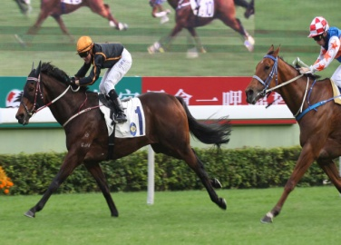](http://www.google.co.uk/url?sa=i&rct=j&q=jockey+&source=images&cd=&cad=rja&docid=YsYK4savclDd2M&tbnid=-jw2FxkH4h02MM:&ved=0CAUQjRw&url=http://syracuserocks.wordpress.com/2011/04/17/pictures-2/horse-and-jockey/&ei=EeojUfLWHM2Y0QWflIGYBA&bvm=bv.42553238,d.d2k&psig=AFQjCNG8WFUkJRcDumI8pC_tnRun8o5aSA&ust=1361394523780647)[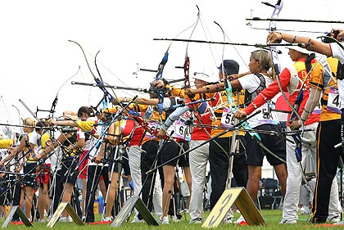](http://www.google.co.uk/url?sa=i&rct=j&q=&esrc=s&frm=1&source=images&cd=&cad=rja&docid=QZkpje6NXffabM&tbnid=c8KQpTIOMoni4M:&ved=0CAUQjRw&url=http://www.virginmedia.com/digital/science/pictures/dark-olympics.php?ssid=2&ei=4-cjUZvjPKyq0AXxz4DQBA&psig=AFQjCNFccneHtbuv8t2XS00rtQBH_vdUCQ&ust=1361393996894860)

Possible side effects:

* Dehydration – this may cause dizziness, muscle cramps, headaches and nausea.
* Long terms effects of kidney damage.
* E.g. Boxers and jockeys may use them to meet weight criteria.
* Drugs that are used to control the heart rate and have a calming and relaxing effect.
* This can result in reduced stress and anxiety levels.
* They help in target sports where precision and steadiness are required.
* They can reduce a person’s heart rate to a dangerous level.
* Drugs that elevate the rate of urine production.
* This speeds up the elimination of fluid from the body to help performers lose weight.
* They may also be taken to reduce the concentration of other banned substances that may be present.

**Diuretics**

Possible side effects:

* Nausea and diarrhoea
* Tiredness
* Depression
* Insomnia & nightmares
* E.g. used in snooker, archery, shooting and curling.

**Beta blockers**

Possible side effects:

* Loss of concentration
* Loss of balance
* Loss of coordination
* Emotional effects – hallucinations (morphine)
* E.g. heroin, methadone, pethidine, morphine.
* Drugs that can be used to reduce pain.
* The drugs act by depressing the central nervous system to give relief from painful injuries.
* This may increase the risk of severe or long-lasting damage.

**Narcotics/**

**Analgesics**

**Stimulants**

Possible side effects:

* Insomnia
* Irritability
* Irregular heart beat
* Increased heart rate
* High blood pressure
* Addiction – (e.g amphetamines = addictive.)
* E.g. cocaine is a recreational drug used by sportspeople including boxers and footballers.
* Drugs that have a effect on the central nervous system such as increased mental or physical alertness.
* This enables athletes to think more quickly.
* They may help to overcome tiredness.
* They are useful in offsetting the effects of lactic acid.
* They can be used in low doses for cold and pain relief medicines.

**Peptide hormones including Erythropoietin (EPO) and Human Growth Hormone (HGH)**

* These are similar to anabolic steroids and aim to increase muscle growth and assist recovery from injury and heavy training.
* They specifically increase the number of red blood cells, therefore allowing extra oxygen to be carried and the dispersal of waste products and lactic acid.
* We produce hormones naturally but they can be produced synthetically by drugs.

**Human Growth Hormone (HGH):**

* Used by athletes to increase muscle development.
* It is a relatively new drug being used as it is thought to have fewer side effects than steroids.
* There is no urine test for HGH but it can be detected through a blood test.

**Erythropoietin (EPO):**

* Used to treat people with anaemia as it increases the production of red blood cells and therefore the amount of haemoglobin available to take up oxygen.
* This increases an athlete’s aerobic capacity which is useful in endurance based events.
* May link to blood doping.

[](http://www.google.co.uk/url?sa=i&rct=j&q=narcotics+drugs&source=images&cd=&cad=rja&docid=mkz_nx3fFEFtTM&tbnid=IXemz67qX_p3qM:&ved=0CAUQjRw&url=http://www.lysergia.com/FeedYourHead/lsdPamphlets.htm&ei=0fYjUbb2AqiO0AW6zYD4CA&bvm=bv.42553238,d.d2k&psig=AFQjCNGJhrGzEqgg9p1E_5JItL96hvGYhw&ust=1361397659169561)

[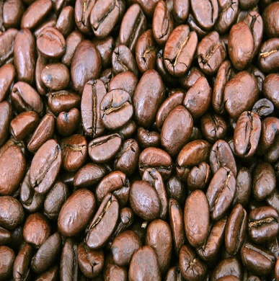](http://www.google.co.uk/url?sa=i&rct=j&q=stimulant+coffee&source=images&cd=&cad=rja&docid=yGz-41LMrujLqM&tbnid=qbzUw6CEp297lM:&ved=0CAUQjRw&url=http://www.searchdictionaries.com/?q=stimulant&ei=jfUjUcGvM6ac0AXO74CIBQ&bvm=bv.42553238,d.d2k&psig=AFQjCNEVqscQBYg59u-SXF9wbsyuopDOmw&ust=1361397463057430)

[](http://www.google.co.uk/url?sa=i&rct=j&q=EPO+paula+radcliffe&source=images&cd=&cad=rja&docid=JivNvOJNlaedfM&tbnid=qsaGaBZOZKdfRM:&ved=0CAUQjRw&url=http://www.paularadcliffe.com/ad_cheats.php&ei=SfQjUaGGIpHK0AXokoG4BQ&bvm=bv.42553238,d.d2k&psig=AFQjCNHkBA5d_MXo5IvMmU0g98FBQm9kbg&ust=1361397169956435)

[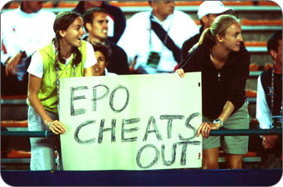](http://www.google.co.uk/url?sa=i&rct=j&q=EPO+paula+radcliffe&source=images&cd=&cad=rja&docid=JivNvOJNlaedfM&tbnid=qsaGaBZOZKdfRM:&ved=0CAUQjRw&url=http://www.paularadcliffe.com/ad_cheats.php&ei=SfQjUaGGIpHK0AXokoG4BQ&bvm=bv.42553238,d.d2k&psig=AFQjCNHkBA5d_MXo5IvMmU0g98FBQm9kbg&ust=1361397169956435)

Possible side effects:

* EPO thickens the blood.
* This makes is more difficult for blood to pass through small capillaries.
* This increases the risk of heart attacks and strokes.

[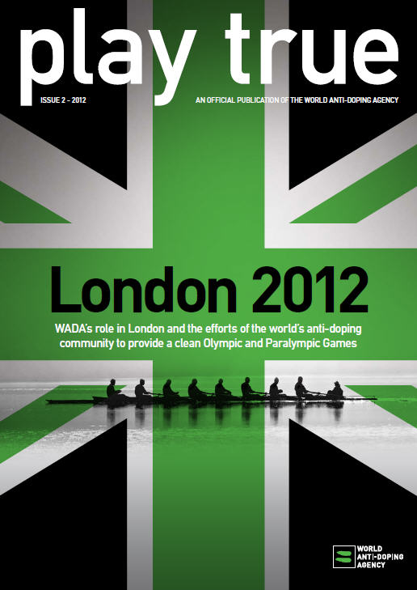](http://www.google.co.uk/url?sa=i&rct=j&q=anti+doping+policy+olympics&source=images&cd=&cad=rja&docid=wHVspI4X79_MGM&tbnid=hlx8FQ3RZWqT8M:&ved=0CAUQjRw&url=http://www.wada-ama.org/en/Resources/Publications/Play-True-Magazine/&ei=QgwkUdrTF4OShgex5IDQAQ&bvm=bv.42553238,bs.1,d.d2k&psig=AFQjCNEqyvH13A8V6QDgmhP7_TaSIvhGYg&ust=1361403276991305)

**Drugs in sport.**

Taking illegal substances to enhance performance is not a new phenomena

- it goes back many years.

* In 1952 – the USSR reportedly used androgenic anabolic steroids

(testosterone) by injection to enhance performance of its weightlifters.

The USA followed suit.

In the 1970s governing bodies began to make it illegal to use drugs in sport.

As a result testing began.

* At the 1972 Olympic Games (Munich) the IOC

(International Olympic Committee) for the first time enforced a full scale

testing programme.

* However, anabolic steroids were not banned until 1975.

In February 1999, the IOC campaigned for:

1. **A single international doping agency.**
2. **A blanket two-year ban for competitors found guilty of drug taking.**

Certain governing bodies – cycling, tennis and football would not agree to a two-year ban. However they insisted on the words ‘specific, exceptional circumstances’.

Today, some countries testing procedures are not as rigorous as others*.*

*Research press releases around Dwain Chambers being allowed to compete in the Olympics, despite his original punishment being a two-year ban plus never being allowed to take part in the Olympics again.*

When athletes test positive for drugs, some claim their innocence.

* Ben Johnson (Canadian, 100m gold medallist in 1988) blamed his positive result on medication taken for a stutter.
* Butch Reynolds (American) blamed testers for mixing up his sample with a guilty East German athlete.

**Most people use recreational drugs on a regular basis.**

* Caffeine – in tea, coffee and some fizzy drinks
* Nicotine from smoking
* Ethanol, more commonly known as alcohol.

**Recreational drugs.**

[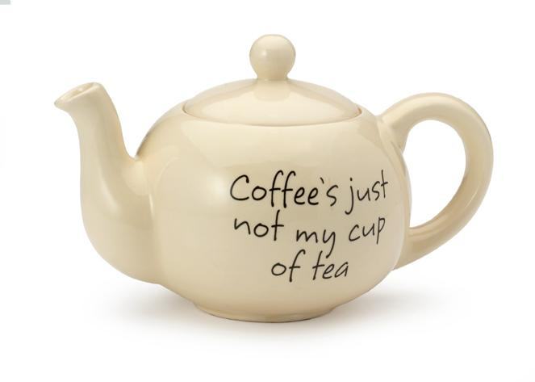](http://www.google.co.uk/url?sa=i&rct=j&q=coffee+is+not+my+cup+of+tea&source=images&cd=&cad=rja&docid=VAd1TTco_wnoaM&tbnid=47KsRHTUufCD0M:&ved=0CAUQjRw&url=http://giftshop.cancerresearchuk.org/coffee-s-just-not-my-cup-of-tea-teapot.html&ei=mZskUczBEYeS0QXhvYGQDw&bvm=bv.42661473,d.d2k&psig=AFQjCNFw6GYtMiKTODYV5F72igsoe5WNOg&ust=1361440002651386)

**Effects on general health.**

* Smoking has been banned in public places since 2007.
* Legal age for buying tobacco products is now 18.
* Coronary heart disease (CHD), not cancer, is the commonest cause of death related to smoking.
* Smoking can cause high blood pressure.
* Smoking just one cigarette can raise the heart rate.
* Medical operations carry a higher risk for smokers.

**Effects on physical activity.**

* Smoking damages the cardiovascular system, in particular:
* The heart
* The oxygen-carrying capacity of the blood and ...
* Blood vessels
* This has negative effect on fitness, especially aerobic fitness, and often results in poorer performance.

**Smoking and nicotine**

[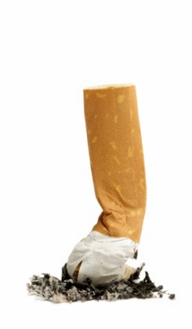](http://www.google.co.uk/url?sa=i&rct=j&q=smoking+&source=images&cd=&cad=rja&docid=WhtvhqU-NBaltM&tbnid=lv1Do6C0lM3gJM:&ved=0CAUQjRw&url=http://www.firesafetynetwork.co.uk/page16.htm&ei=OKAkUfTXI4e50QXYpIGQDw&bvm=bv.42661473,d.d2k&psig=AFQjCNF61FWNajYj3JqvitLfgBffXFpIYg&ust=1361441159378197)

**Nicotine.**

* Is a stimulant which raises alertness.
* Nicotine is an addictive drug – the more people smoke, the harder they find it to stop.

**Effects on general health and in sport.**

* Alcohol is banned in some sports, such as shooting or archery, where it may be used as a sedative (having calming effects).
* Alcohol is also banned in sport where it is considered a safety risk, such as motor sports, because it slows down reaction times and impairs judgement.
* Alcohol can cause extra urine to be produced, which increases the risk of dehydration.
* Long term effects of Alcohol include a form of liver damage know as cirrhosis.

**Alcohol**

[](http://www.google.co.uk/url?sa=i&rct=j&q=alcohol&source=images&cd=&cad=rja&docid=5XfvytfDeU-lMM&tbnid=sqdnlrmwN91aXM:&ved=0CAUQjRw&url=http://www.cmfblog.org.uk/2013/02/07/thirst-for-life-raising-alcohol-prices-to-save-lives/&ei=T6IkUenWD6XW0QXBkYGQDw&bvm=bv.42661473,d.d2k&psig=AFQjCNE2Vcusv5Lt4ixnLQir3mGug-KHmQ&ust=1361441704752514)

**Socially unaccepted drugs.**

* Are illegal and unacceptable to most people. These include:
* heroin,
* cocaine,
* LSD,
* amphetamines,
* barbiturates,
* cannabis and
* ecstasy

* All of these have negative effects and can be dangerous, in some cases leading to death.

**Socially accepted drugs.**

* Those that may be prescribed by a doctor or which can be brought over the counter, such as paracetamol or aspirin, to treat medical conditions.

[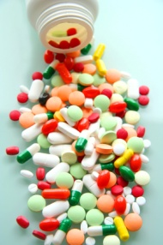](http://www.google.co.uk/url?sa=i&rct=j&q=drugs&source=images&cd=&cad=rja&docid=6Aiw2O_6UVnncM&tbnid=dxbJSVWpXjO0xM:&ved=0CAUQjRw&url=http://revisewithrachie.com/revision-sheets/abnormality/the-biological-treatments-for-abnormality/&ei=EKgkUee6CIW10QXPsoCQDw&bvm=bv.42661473,d.d2k&psig=AFQjCNF7VeWITkKiKXYpjXDmfJ2JnLZA0w&ust=1361443206196496)

[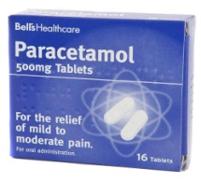](http://www.google.co.uk/url?sa=i&rct=j&q=paracetamol&source=images&cd=&cad=rja&docid=cObe43t75pYy6M&tbnid=Dplhlk-Sj8SuWM:&ved=0CAUQjRw&url=http://www.poundland.co.uk/product-range/a-z/paracetamol---16-tablets/&ei=mKgkUeykHuin0AXMwoCQDw&bvm=bv.42661473,d.d2k&psig=AFQjCNG_L3b0HFWxBsypggjSm2CqtUbzmA&ust=1361443334161508)

**Past exam question (June 2011)**

Several different categories of performance enhancing drugs are listed in the table below.

|  |  |  |
| --- | --- | --- |
| Anabolic steroids | Beta blockers | Diuretics |
| Narcotic analgesics | Stimulants | Peptide hormones/EPO |

(a) Using this information, identify the relevant category of drug referred to in each of the following statements.

(i) Long distance runners are more likely to use this class of drug than sprinters. **(1)**

.......................................................................................................................................................................................................

(ii) Weight lifters may use this class of drug to mask the pain of a torn muscle. **(1)**

.......................................................................................................................................................................................................

(iii) Archers may use this class of drug because of its calming effect to improve their accuracy. **(1)**

.......................................................................................................................................................................................................

(iv) Some performers will use this class of drug to mask the use of other types of drugs. **(1)**

.......................................................................................................................................................................................................

(b) All of these drugs have potentially harmful side effects. Explain why, despite the risks, some performers will still use them. **(1)**

..............................................................................................................................................................................................................................................................................................................................................................................................................

(c) Give an example of a possible harmful side effect of diuretics. **(1)**

..............................................................................................................................................................................................................................................................................................................................................................................................................

**(Total for Question 8 = 6 marks)**

**8a (i)** Peptide hormones/EPO **8a (ii)** Narcotic analgesics *Do not accept narcotic(s)* **8a (iii)** Beta blockers

**8a (iv)** Diuretics **8b** Pressure/to win/wants to be the best/prize money/fame/improve performance/gain advantage/train harder (or longer)/gain outweighs risks / quicker recovery from injury/equiv *Do not accept addictive / won’t get caught* **8c** Any one from: Dehydration, Nausea/sickness, Kidney/liver failure/damage, *Do not accept damage to organs / heart problems /death.*

**Risk: a situation or activity involving exposure to danger.**

***Most physical activities and sports have some sort of risk attached.***

***Some activities carry higher risks than others, however risk can be minimised.***

**1.2.1: Physical activity and your healthy mind and body.**

**Risk assessment and preventing injuries.**

|  |  |  |  |  |  |  |
| --- | --- | --- | --- | --- | --- | --- |
| **Minimising risk.** | | | | | | |
| **Warming up/cooling down** | | **Checking equipment and facilities** | **Protective equipment and clothing** | | | **Footwear** |
| * Warming muscles gradually helps to prevent injury. * A cool down disperses lactic acid. Does not prevent injury but prevents soreness and aches. | | * Organisers, officials and participants are responsible. * Generally due to the environment – waterlogged pitch, icy court, insufficient lighting. | * Football – boots, shin pads. * Hockey – shin pads, mouth guard, goalkeeper pads. * Cricket - batsman helmet. * Sailing-lifejacket, warm clothing-specially designed wet suits. * Rising – hat. * Jewellery should be removed/taped so as to prevent injuries to self and others. | | | * Helps performance- footballers have studs to provide more grip * Provides support to bones muscles and joints * Provides comfort. |
| **Balanced competition: To create a balanced and fair competition, following factors should be considered.** | | | | | | |
| **Weight categories** | **Mixed/single sex** | | | **Age** | **Handicap system** | |
| * Equalises competition. * Safety purposes. * Boxing match competitors by their weight to protect them. * Weightlifting – weight divisions. | * In most sports men play again men and women play against women. * For safety – especially in contact sports-rugby and hockey. * For fair competition – athletics and swimming. * Racket sports – tennis, table tennis and badminton mixed doubles competitions. Allows clear opportunity for men and women to compete fairly in open competition. | | | * Competitions usually set by age. * Talented performers sometimes play out of age group. * Overuse injuries are frequent in young athletes. * Age categorising does not guarantee competitors will be of equal height and weight. * In other age categories, often have senior and veteran competitions. Generally for safety reasons. | * Balances competition. * Used in golf. * Ensures players play with players of equal/similar ability. * Karate and judo have clear skill levels and players take part in competitions according to their ability. | |

**Playing to the rules of competition.**

* Allows fair competition.
* Allows safety.
* Allows games to flow. If rules are broken, participants punished-could mean a lifetime ban.
* Professional fouls occur occasionally in sport – players deliberately act to stop or affect play.
* Such behaviour goes against spirit of fair play.
* Over aggression and professional fouls could cause serious injuries and threaten a player’s career.
* Fines/bans in place for breaking rules and jeopardising ‘spirit of the game’.

[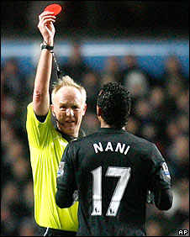](http://www.google.co.uk/url?sa=i&rct=j&q=red+card+football&source=images&cd=&cad=rja&docid=UbPYdmLQZj2MKM&tbnid=qA7vUILOSZONAM:&ved=0CAUQjRw&url=http://news.bbc.co.uk/sport2/hi/football/teams/m/man_utd/8509703.stm&ei=RrgkUe2YFuiJ0AW3qYGYDw&bvm=bv.42661473,d.d2k&psig=AFQjCNHy11KFpP77Geyap3MWbPSJZ4MYMA&ust=1361447339260881)

**Physical readiness.**

* Complete a PAR-Q and medical examination if necessary.
* Choosing activities that are suited to your fitness level and body type
* Know and use the right techniques for your sport and training regularly
* Follow the **rules** and **play fairly**.

[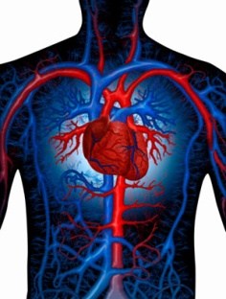](http://www.google.co.uk/url?sa=i&rct=j&q=&esrc=s&frm=1&source=images&cd=&cad=rja&docid=fTbyvRMNMkivzM&tbnid=934iqD1_fdSUfM:&ved=0CAUQjRw&url=http://www.proprofs.com/flashcards/cardshowall.php?title=anatomy-physiology_169&ei=KuYkUf3PBeiZ0QXD5oCYDw&bvm=bv.42661473,d.d2k&psig=AFQjCNFpiuZvERpyEM3N0eyQeqN7S_rK9w&ust=1361459072240518)[](http://www.google.co.uk/url?sa=i&rct=j&q=&esrc=s&frm=1&source=images&cd=&cad=rja&docid=4AgcvfBopMGpHM&tbnid=PBgKB2eKVMkEXM:&ved=0CAUQjRw&url=http://scriptshadow.blogspot.com/2010/10/blood-list-is-out.html&ei=8-QkUaSqE4yU0QWo7YCQDw&bvm=bv.42661473,d.d2k&psig=AFQjCNHEevn2Zo-sC-UJKjv-UKPCARUZOw&ust=1361458772420754)

**1.2.2: A healthy active lifestyle and your cardiovascular system.**

**The cardiovascular system during exercise.**

[](http://www.google.co.uk/url?sa=i&rct=j&q=&esrc=s&frm=1&source=images&cd=&cad=rja&docid=QBCZJXyWC6qvCM&tbnid=tVZRr19kCb2zIM:&ved=0CAUQjRw&url=http://thewordden.blogspot.com/2012/04/nuts-and-bolts-pictograms.html&ei=auQkUdraAqqb0QXHgYGYDw&bvm=bv.42661473,d.d2k&psig=AFQjCNEw67QLzYxwXpon4dbSjKj6b8zfXA&ust=1361458650323008)

**The heart**

**The cardiovascular system.**

**Blood vessels**

**Blood**

Run throughout body allowing blood to travel everywhere.

Include: arteries, veins and capillaries.

* Supplies body with oxygen and nutrients.
* Removes waste products e.g. carbon dioxide.

Muscular pump which pushes blood throughout the many blood vessels in the body.

|  |  |  |  |
| --- | --- | --- | --- |
| **What happens to the cardiovascular system during exercise?** | | | |
| **Increased heart rate** | **Increased blood pressure** | | |
| * Exercise makes the body work harder, therefore muscles require more oxygen and the body needs more nutrients, such as glycogen, to function properly. * As oxygen and nutrients are carried by the blood to muscles, the heart works faster to pump the blood around the body. Therefore heart rate (bpm) increases. | Blood pressure increases during exercise as more blood is pumped around the body, increasing the pressure on the blood vessels. | | |
| **Blood pressure.** | | |
| **The heart makes two beating sound. The first is called systole. The second is called diastole.** | | |
| **Systolic blood pressure** | | **Diastolic blood pressure** |
| Pressure in the arteries as the heart contracts and forces blood through the aorta and into the body. This increases during activity as body requires more blood. | | Pressure of blood during the relaxation phase between heart beats. |
| Pulse pressure: The difference between systolic and diastolic blood pressure. | | |

**Immediate physiological effects of exercise on the body.**

[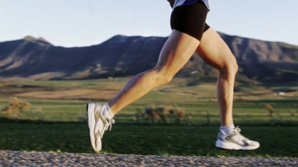](http://www.google.co.uk/url?sa=i&rct=j&q=&esrc=s&frm=1&source=images&cd=&cad=rja&docid=yi9aOlTaWJOdXM&tbnid=hjUdpCVnVa7qWM:&ved=0CAUQjRw&url=http://www.biokineticspt.com/blog/tag/running&ei=X-4kUeTsI8bA0QXOpoCgDw&psig=AFQjCNFjlZDFn9Uet3xv330wF_lOApx3Tw&ust=1361461214240803)

**Sweating starts and body requires fluids.**

The body can cope with a small rise in temperature but after this it will try to cool down 🡪begin to sweat.

Sweat is released from the skin and evaporates when it reaches the surface. In hot conditions – sweating increases, less urine is produced. The salt lost trough sweating must be replaced to remain balanced otherwise cramp may occur.

A lack of water and salt can result in fainting/collapsing.

**Breathing becomes faster and deeper.**

Allows more oxygen into your lungs that can be transported by the blood around the body to the muscles.

**Muscles begin to ache.**

Muscles need energy and oxygen to work. If not enough oxygen muscles will respire anaerobically 🡪 lactic acid is produced.

**Body temperature increases.**

During exercise working muscles generate heat.

Body temperature is regulated by heat radiating from the skin and water evaporating through sweat.

Shivering produces heat to raise body temperature.

**1.2.2: A healthy active lifestyle and your cardiovascular system.**

**Regular exercsie and the cardiovascular system.**

|  |  |  |
| --- | --- | --- |
| **Regular exercise/long-term participation has many benefits. The most important is that the heart becomes more efficient.** | | |
| **Other effects of regular exercise on the cardiovascular system.** | | |
| **Decreased resting heart rate** | Heart gets bigger and stronger with training therefore it supplies the same amount of blood with fewer beats. If it is beating fewer times, it is more efficient - less strain on the heart. [http://2.bp.blogspot.com/-mVDgEAZDNdg/TrwEThpXuTI/AAAAAAAAApM/mSN2Rg1n4mY/s1600/heart_beat.jpg](http://www.google.co.uk/url?sa=i&rct=j&q=&esrc=s&frm=1&source=images&cd=&cad=rja&docid=BEHSJxLAZwOipM&tbnid=AHBQo_MPp7YFaM:&ved=0CAUQjRw&url=http://eastandwestrunning.blogspot.com/2011/11/heart-rate-all-time-high.html&ei=hfckUdnkE-ek0QXTlICYDw&psig=AFQjCNEasRHAaLcmKYCq0RRWMC0Q9NnUKA&ust=1361463524150284) | |
| **Faster heart rate recovery** | The speed at which the heart returns to normal after exercise. This time is takes to return to resting levels will be faster. | |
| **Increased stroke volume** | Stroke volumes increases as the heart becomes more efficient and stronger.  Stroke volume increases at rest and work. | **Stroke Volume – the volume of blood pumped out of the heart by each ventricle during one contraction.** |
| **Increased cardiac output** | Cardiac output is governed by heart rate and stroke volume which both change during exercise – therefore increasing cardiac output.  Stroke volume x heart rate = cardiac output | **The amount of blood ejected from the heart in one minute.** |
| **Reduced blood pressure** | Regular exercise can reduce blood pressure. This may link to weight loss as if you are overweight you are at risk of having high blood pressure. | Factors that affect blood pressure include age, sex, muscular development, stress and tiredness. |
| **Healthy veins and arteries** | Fitness increases the number of capillaries within the heart muscles.  [http://2.bp.blogspot.com/-IwkqwEftGlk/TZvo4EqIzzI/AAAAAAAAAAQ/SvsTPphyEAY/s1600/heart+scan.jpg](http://www.google.co.uk/url?sa=i&rct=j&q=&esrc=s&frm=1&source=images&cd=&cad=rja&docid=NtKzv7O5mQqu3M&tbnid=bGNGHgnvIcMDUM:&ved=0CAUQjRw&url=http://peter-eloisa.blogspot.com/2011/04/heart-and-tree.html&ei=yvgkUbvRC8G-0QXuroGYDw&psig=AFQjCNG9lUKxTnCunjZtPkhIhaC3nu9elg&ust=1361463868162654)It allows blood vessels to remain more flexible and efficient. This reduces the risk of coronary heart disease. | |

[](http://www.google.co.uk/url?sa=i&rct=j&q=&esrc=s&frm=1&source=images&cd=&cad=rja&docid=HuOhO057F8vnaM&tbnid=v9rL5X7IoO6rGM:&ved=0CAUQjRw&url=http://brickartist.com/gallery/open-heart/?ref=recent&ei=fvkkUc6XMoyU0QWo7YCQDw&psig=AFQjCNGxfVl-bVO4ubClu54Xetx7JzwNQg&ust=1361463987759280)

Causes of heart disease include:

* Hereditary conditions
* Infections
* Narrowing of the coronary arteries
* High blood pressure
* Smoking.

**Coronary heart disease**

**(CHD)**

Heart disease causes more deaths in the developed world than any other disease.

**Past exam question (June 2012)**

**7** The following statements are effects of participation in exercise and physical activity on the cardiovascular system. State whether the effect is immediate or long term.

**Immediate or long term effect?**

(i) Increased heart rate ....................................................................................................

(ii) Increased cardiac output ............................................................................................

(iii) Increased maximum cardiac output .......................................................................(Total for Question 7 = 3 marks)

**7(i)** Immediate **7(ii)** Immediate **7(iii)** Long term

[](http://www.google.co.uk/url?sa=i&rct=j&q=&esrc=s&frm=1&source=images&cd=&cad=rja&docid=E_TDuBYl_0c4LM&tbnid=EE1Dd1Z4V_JTsM:&ved=0CAUQjRw&url=http://olszowy.com.pl/heart-outline-images&page=5&ei=uAElUdoIpazRBZrBgJAP&bvm=bv.42661473,d.d2k&psig=AFQjCNEge9P4qg_MnI6n8QHWU9M70hFzgg&ust=1361466151921010)

**1.2.2: A healthy active lifestyle and your cardiovascular system.**

**The effect of lifestyle on the cardiovascular system.**

|  |  |  |
| --- | --- | --- |
| **Rest: The period of time allocated to recovery.** | | |
| **Rest is essential to allow the body to recover and adapt. It allows the heart to grow in size and thickness and the number of capillaries to increase.** | | |
| **Factors that may have a negative effect on the cardiovascular system and increase the risk of coronary heart disease.** | | |
| **High cholesterol**  [http://blogs.thenews.com.pk/blogs/wp-content/uploads/2012/07/hdl.jpg](http://www.google.co.uk/url?sa=i&rct=j&q=&esrc=s&frm=1&source=images&cd=&cad=rja&docid=FqnYncn3PH06vM&tbnid=AKtbQwHHY0M4bM:&ved=0CAUQjRw&url=http://blogs.thenews.com.pk/blogs/2012/07/low-cholesterol-diet-%E2%80%93-a-boon-for-people/&ei=kQAlUbr4Na-b1AXij4CQDw&bvm=bv.42661473,d.d2k&psig=AFQjCNFCz502-F937kY-A_znxbNNAEuFpw&ust=1361465789465777) | Cholesterol is a fatty substance carried in the blood by lipoproteins.   * High density lipoprotein (HDL) contains more protein than fat and is often referred to as the ‘good cholesterol’. Carries cholesterol away from the arteries to the liver for removal from the body. Fruit and Vegetables are HDL rich. * Low Density Lipoprotein (LDL) consists mainly of fat and is known as the ‘bad cholesterol’. It can lead to a build up of plaque which restricts blood flow in the arteries. Blockages in vessels mean they have to work harder to pump blood around the body therefore increasing blood pressure. | * High cholesterol can be caused by a diet high in LDL. * Cholesterol only becomes a problem when the level in the blood is too high. This leads to deposits in the vessels and heart problems. * It can increase the risk of CHD as well as narrowing of arteries and consequently heart attacks. |
| **Recreational drugs** | * **Cigarettes** raise the blood pressure as they release adrenaline which causes arteries to constrict and the heart to beat faster. * **Tobacco smoke** is a major risk factor of heart disease. * **Smoking** lowers HDL cholesterol (good cholesterol) levels and increases the tendency for blood to clot which can lead to heart attacks or strokes. * **Alcohol** in moderation it thought to increase HDL therefore in the long term can help lower blood pressure, HOWEVER too much alcohol and binge drinking can have serious adverse effects. * **Prescription drugs** can be taken to control blood pressure. Some prescription drugs taken for other illnesses may cause an increase in blood pressure therefore they may need to take additional medication to control blood pressure. | |
| **Sedentary lifestyle and lack of exercise (hypokinetic disease)** | * Inactivity means the cardiovascular system does not receive the benefits of exercise. Sedentary living is also believed to be the main reason for increased obesity. | |
| **Stress** | * The stress that may increase the risk of CV disease is different to the stress felt before taking an exam. * Negative stress builds up over time and can lead to an increase in blood pressure and elevated heart rate. It may also lead to depression and mood swings. | |

With training the heart muscle increases in size, thickness and strength, the chambers increase in volume and the whole heart gets bigger. This allows you to work harder for longer and less stress is placed on the heart.

Cardiovascular exercise and improvements in cardiovascular fitness can reduce the risk of coronary heart disease, improve the cardiovascular system and helps to reduce blood pressure.

In summary...

The functions of the respiratory system:

* To bring oxygen into the body
* To take carbon dioxide out of the body

An efficient respiratory system allows more oxygen to reach the blood and consequently the muscles.

**1.2.3: A healthy active lifestyle and your respiratory system.**

**The respiratory system.**

**The gaseous exchange.**

**Oxygen debt.**

When the body works hard, it may need more oxygen than it can get. This is known as oxygen debt. This could occur at

the end of a

400m race.

**Gaseous Exchange.**

* Air passes down the trachea and bronchi into the lungs. It travels through the bronchioles into the alveoli.
* In the alveoli oxygen diffuses into the blood to be

sent around the body.

* At the same time, carbon dioxide from the body is

released into the alveoli where it is exhaled.

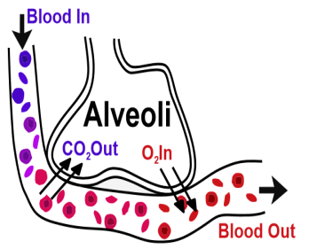

[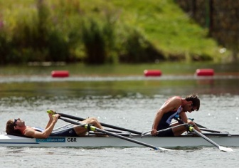](http://www.google.co.uk/url?sa=i&rct=j&q=&esrc=s&frm=1&source=images&cd=&cad=rja&docid=z3U65_G9n6eaiM&tbnid=kDHxy-ofkCsazM:&ved=0CAUQjRw&url=http://www.mirror.co.uk/sport/other-sports/zac-purchase-and-mark-hunter-devastated-1216389&ei=vAUmUdjiEoic0AXo8oHYDA&psig=AFQjCNF2CyYKsTe2fpfrP_ih02CqvgWGog&ust=1361532708602379)

**How the respiratory system works.**

**THE GASEOUS EXCHANGE.**

[](http://www.google.co.uk/url?sa=i&rct=j&q=&esrc=s&frm=1&source=images&cd=&cad=rja&docid=n1IyBCyiWVHZpM&tbnid=cVOqAeqETZx9SM:&ved=0CAUQjRw&url=http://www.bedford.gov.uk/environment_and_planning/pollution/air_quality.aspx&ei=MQ0mUeezMIWR0AXKl4D4Bg&psig=AFQjCNEFBA33NDe0tvws7WxbTXXBrk1QZg&ust=1361534632376425)

|  |  |
| --- | --- |
| **Inhaled and exhaled air.** | |
| **Inhale (air into the lungs)**  [http://clipartist.info/RSS/png/polmoni_lungs_polmoni-1331px.png](http://www.google.co.uk/url?sa=i&rct=j&q=&esrc=s&frm=1&source=images&cd=&cad=rja&docid=4vItU8cYW3NSyM&tbnid=KnGu8-0ZCDFgqM:&ved=0CAUQjRw&url=http://clipartist.net/uncategorized/polmoni-lungs-polmoni-rss-openclipart-org-commons-wikimedia-org/&ei=lxomUfjNNYKx0QW_8oC4BA&bvm=bv.42661473,d.d2k&psig=AFQjCNHAKDQqy6lwC_gHlwv51faOcTEghw&ust=1361538027407836) | **[http://clipartist.info/RSS/png/polmoni_lungs_polmoni-1331px.png](http://www.google.co.uk/url?sa=i&rct=j&q=&esrc=s&frm=1&source=images&cd=&cad=rja&docid=4vItU8cYW3NSyM&tbnid=KnGu8-0ZCDFgqM:&ved=0CAUQjRw&url=http://clipartist.net/uncategorized/polmoni-lungs-polmoni-rss-openclipart-org-commons-wikimedia-org/&ei=lxomUfjNNYKx0QW_8oC4BA&bvm=bv.42661473,d.d2k&psig=AFQjCNHAKDQqy6lwC_gHlwv51faOcTEghw&ust=1361538027407836)Exhale (air out of the lungs)** |
| Oxygen **20.95%** | Oxygen **16%** |
| Nitrogen **79%** | Nitrogen **79%** |
| Carbon dioxide **0.04%** | Carbon dioxide **4%** |
| Water vapour **0.01%** | Water vapour **1%** |

[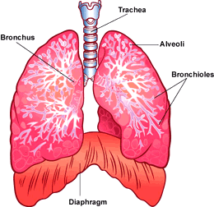](http://www.google.co.uk/url?sa=i&rct=j&q=&esrc=s&frm=1&source=images&cd=&cad=rja&docid=icmD6gptXPNdvM&tbnid=1QT9_ilyKB8olM:&ved=0CAUQjRw&url=http://www.childrenscolorado.org/wellness/info/kids/54039.aspx&ei=NR8mUf-ICPKR0QXyiYHoAQ&psig=AFQjCNGTBAGZTPPdLFgBqM5A1jDG-9V-CA&ust=1361539228301344)

* The body needs less oxygen at rest as muscles are not working so hard.
* An average person breathes about 21 times a minute during rest.
* More air is taken in with each breath during exercise as the muscles require

more oxygen.

* Regular exercise increases lung capacity and enables more oxygen to be

taken in with each breath.

|  |  |
| --- | --- |
| **Tidal volume and vital capacity help to estimate the efficiency of the respiratory system.** | |
| **Tidal Volume** | **Vital capacity** |
| The amount of air inspired and expired with each normal breath at rest or during exercise. | The greatest amount of air that can be made to pass into and out of the lungs by the most forceful inspiration and expiration. Normally this is about 4-5 litres. |

**Past exam question (June 2011)**

1(h) Which of the following is a long-term effect of participation in exercise and physical activity on the respiratory system? **(1)**

**A** Increase in blood flow to the lungs

**B** Increase in oxygen debt

**C** Increase in vital capacity

**D** Increase in breathing rate

**Past exam question (June 2010)**

**10.** (a) Name the term being described in each of the following statements.

(i) The number of times the heart beats each minute.

................................................................................................................................**(1)**

(ii) The amount of air breathed in or out of the lungs in one breath.

................................................................................................................................**(1)**

(iii) The volume of blood pumped out of the heart by each ventricle during one

contraction.

................................................................................................................................**(1)**

(b) Which two of the terms used in your answer to (a) combine to give cardiac output?

.......................................................................................................................................**(1)**

**1(h)** C **10a (i)** heart rate **10a (ii)** Tidal volume**10a (iii)** Stroke volume **10b** Stroke volume and heart rate.

**1.2.3: A healthy active lifestyle and your respiratory system.**

**Immediate and long-term effects of exercise on the respiratory system.**

|  |  |  |
| --- | --- | --- |
| Immediate and short-term effects of participation in exercise and physical activity on the respiratory system. | | |
| **Breathing quickens and deepens** | * However quickly the heart beats, it cannot carry enough oxygen if the oxygen is not reaching the lungs, therefore breathing is greatly affected by exercise. * The efficiency of breathing depends on how much oxygen can be removed from the air and the efficiency of the alveoli. | The most important structures in oxygen uptake are the alveoli, these can be damaged, for example by smoking. |
| **Oxygen debt.** | * Oxygen used during anaerobic exercise often results in oxygen debt and is repaid through deep gasping breaths after the activity. * This allows as much oxygen as possible to be taken into the respiratory system whilst removing as much carbon dioxide as possible. | Oxygen debt =  The extra oxygen consumed during recovery from a period of strenuous physical activity, compared with the amount which would usually have been consumed over the same length of time at rest. |
| **Effects of regular participation in and long-term benefits of exercise and physical activity.** | | |
| **Increased oxygen delivery** | * Increased oxygen delivery to the working muscles therefore the body will cope better during exercise. | |
| **Carbon dioxide is removed more efficiently** | * Carbon dioxide is removed more efficiently allowing the body to cope with greater production of carbon dioxide during exercise. | |
| **Vital capacity increases** | * Vital capacity increases as the lungs become more efficient. | |
| **More alveoli** | * More alveoli are available for gaseous exchange – this means more oxygen can be absorbed by the capillaries and more carbon dioxide removed from the body. Therefore vo2 max (aerobic capacity) also increases. | |
| **Increased number of capillaries** | * Increased number of capillaries surrounding the alveoli means more oxygen can get into the blood and carbon dioxide out of the blood. * Increased number of capillaries surrounding the alveoli means more oxygen can get into the blood and carbon dioxide out of the blood. | |

|  |
| --- |
| **The effects of smoking on the alveoli and gaseous exchange.** |
| * Smoking serious affects the process of gaseous exchange in the lungs. * Smoke damages the lungs, especially the alveoli, making them less stretchy and therefore less efficient. * This means it is more difficult to get oxygen in and carbon dioxide out, therefore smokers may become short of breath. * This requires their hearts to work harder to get the oxygen their bodies need, consequently they feel tired. * [http://smokerslungs.net/wp-content/uploads/2009/11/smokers-lungs-comparison1.png](http://www.google.co.uk/url?sa=i&rct=j&q=&esrc=s&frm=1&source=images&cd=&cad=rja&docid=tqjwGJHjVRKDQM&tbnid=9mb-4Osm7lcM9M:&ved=0CAUQjRw&url=http://smokerslungs.net/smokers-lungs-comparison&ei=RlkmUbzlEe-20QXFxIEI&psig=AFQjCNHnrWDJCcDhOjVuosT0APdKYvI1AA&ust=1361554073359715)A government ban on smoking in public places is attempting to tackle the problem. |

|  |
| --- |
| **An efficient respiratory system aids the cardiovascular system.** |
| The respiratory system provides a constant supply of oxygen for the muscles and removes the waste product (carbon dioxide). This is why efficient cardiovascular and respiratory systems are so important to everyone!  The are both vital to both health and performance in sport and physical activity. |

[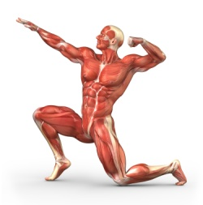](http://www.google.co.uk/url?sa=i&rct=j&q=muscle+fibres&source=images&cd=&cad=rja&docid=p5fo-LlSKvHdzM&tbnid=EBvWTJmGAy9d_M:&ved=0CAUQjRw&url=http://www.interactive-biology.com/2012/an-introduction-to-skeletal-muscle-contraction/&ei=CGQmUciWGMLs0gXp8oG4CQ&bvm=bv.42661473,d.d2k&psig=AFQjCNH3V7tX-heamK35h44PNXGzCqj2gw&ust=1361556850213071)

**The muscular system – what does it do?**

* Causes movement through the contraction and relaxation of muscles.
* Defines body shape and helps maintain posture.
* Muscles can work voluntary (conscious control by the body) or involuntary
* (in the internal organs).

**1.2.4: A healthy active lifetsyle and your muscular system.**

**The muscular system.**

[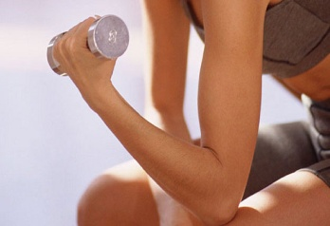](http://www.google.co.uk/url?sa=i&rct=j&q=bicep+curl&source=images&cd=&cad=rja&docid=pdS9HJs-JQmn_M&tbnid=-aDgvUYaKoJ0hM:&ved=0CAUQjRw&url=http://articles.elitefts.com/training-articles/biceps-blowout-a-case-for-biceps-curls/&ei=rGImUcD6IOqc0QW73oFg&bvm=bv.42661473,d.d2k&psig=AFQjCNG6nb7BYsodRuJ488yhDNb1lD0NsQ&ust=1361556512539792)

**Voluntary muscles.**

* These muscles cause movement.
* They are consciously controlled.
* They can be trained to work for longer without tiring.
* We can improve the flexibility of these muscles to allow a greater range of movement.

**Muscles and movement.**

* Muscles are attached to bones by tendons and are made up of a number of **muscle fibres.**
* Muscle fibres contract causing movement – they pull against the skeleton but cannot push.
* Therefore muscles are arranged in **antagonistic pairs** – as one contracts the other relaxes. e.g. The biceps and

triceps, the quadriceps and hamstrings.

**The muscle doing the work (contracting) and creating the movement is called the agonist.**

**The muscle which is relaxing and letting the movement take place is called the antagonist**

To extend the elbow, the bicep relaxes and the tricep contracts.

To flex the elbow, the bicep contracts and the tricep relaxes.

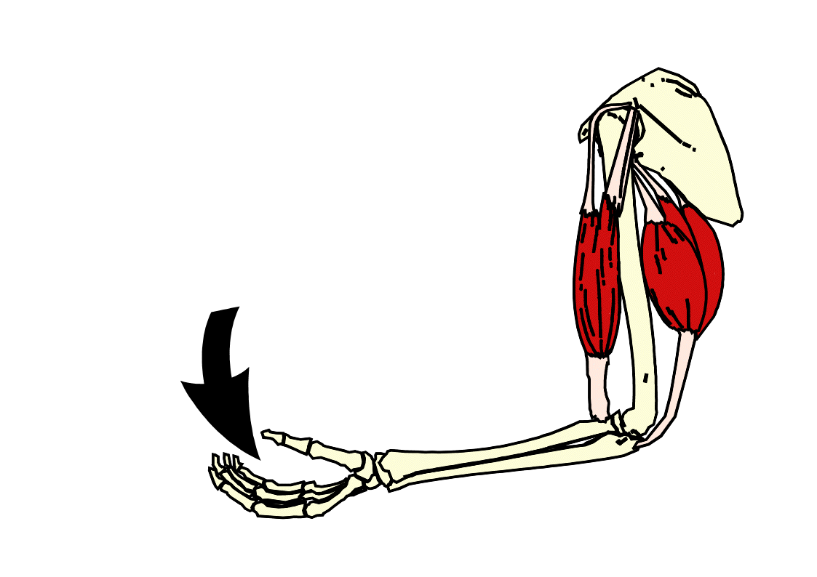

**Biceps**: agonist contracting muscle

**Triceps**: agonist contracting muscle

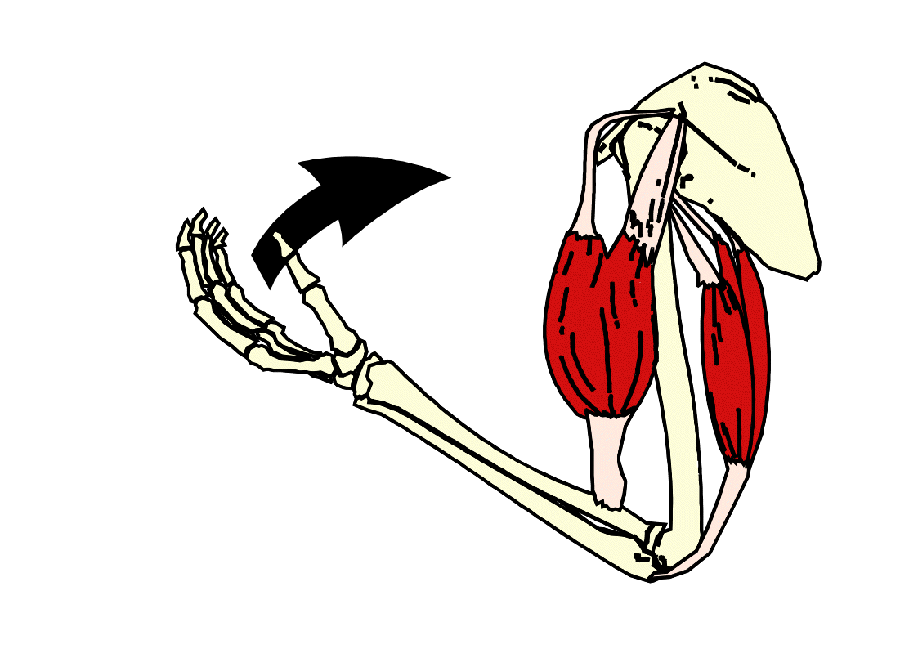

**Triceps:** antagonist relaxing muscle

**Biceps:** antagonist relaxing muscle

* The same applies in the leg to flex and extend the knee joint.
* Flexion – hamstrings contract (agonist), quadriceps relax (antagonist).
* Extension – quadriceps contract (agonist), hamstrings relax (antagonist).

**There are 11 muscles you need to know.**

[](http://www.google.co.uk/url?sa=i&rct=j&q=number+11&source=images&cd=&cad=rja&docid=V8flZXY7PF75xM&tbnid=cWFUoFbgEPZi1M:&ved=0CAUQjRw&url=http://www.sodahead.com/fun/why-isnt-the-number-11-pronounced-onety-one/question-1135767/&ei=NXMmUZvWEqS40QWG6ICQDg&bvm=bv.42661473,d.d2k&psig=AFQjCNER2KdYkLwrWI-4Y41ZI4N70pgyAw&ust=1361560714758091)

**Back view**

**Front view**

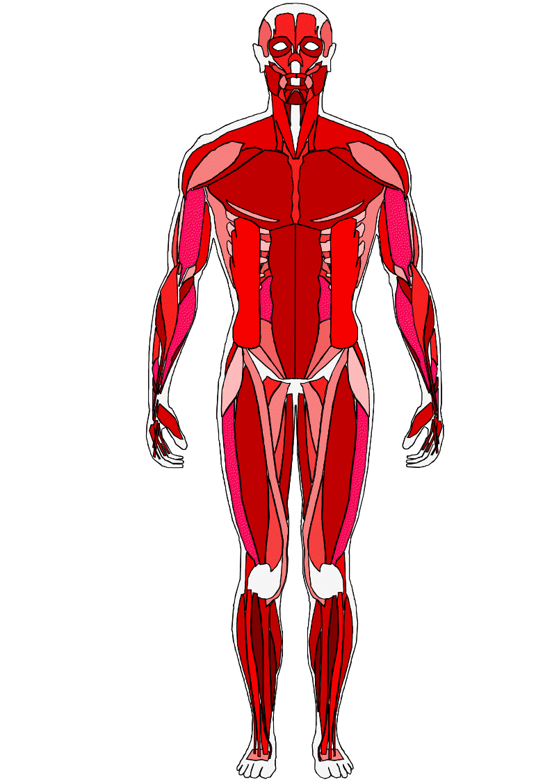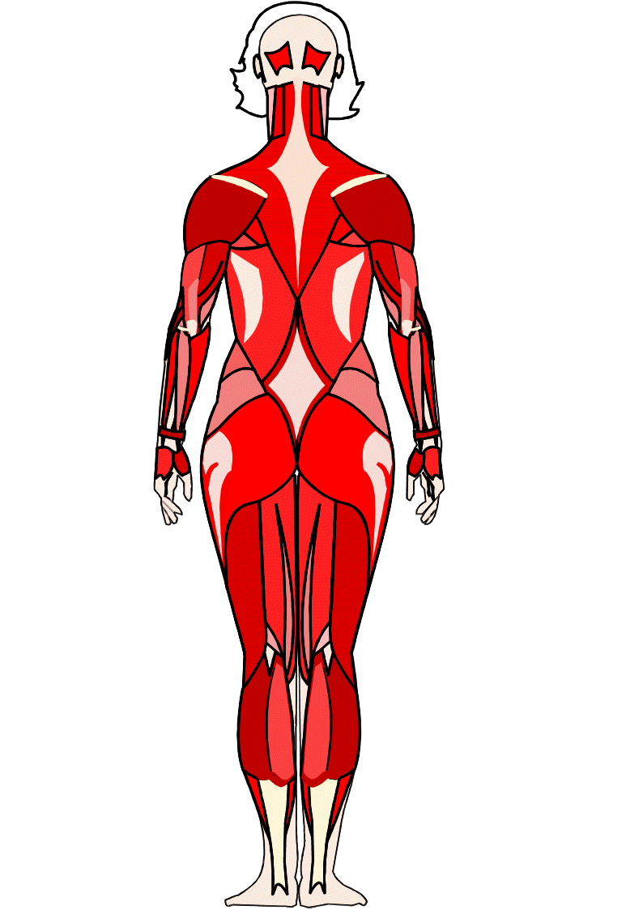

**Trapezius**

**Deltoids**

**Triceps**

**Pectorals**

**Biceps**

**Latissimus Dorsi**

**Abdominals**

**Gluteals**

**Quadriceps**

**Hamstrings**

**Gastrocnemius**

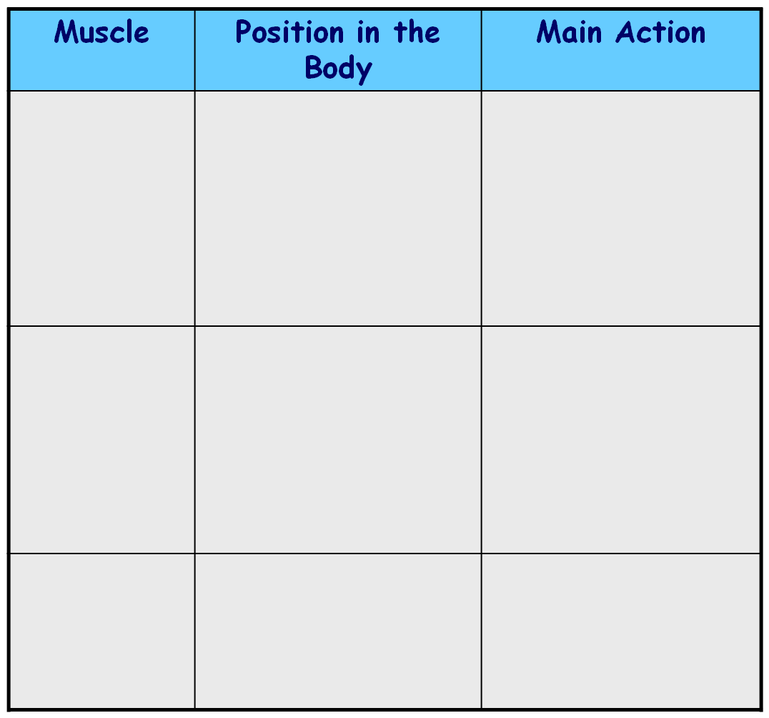

**Latissimus**

**Dorsi**

**Triceps**

At the back of the body, either side of the chest.

At the top of each arm at the back.

Rotates upper arm at the shoulders.

Extends the arms at the elbow.

**Trapezius**

In the centre of the chest at the back of the body, spreading up.

Rotates the shoulders backwards.

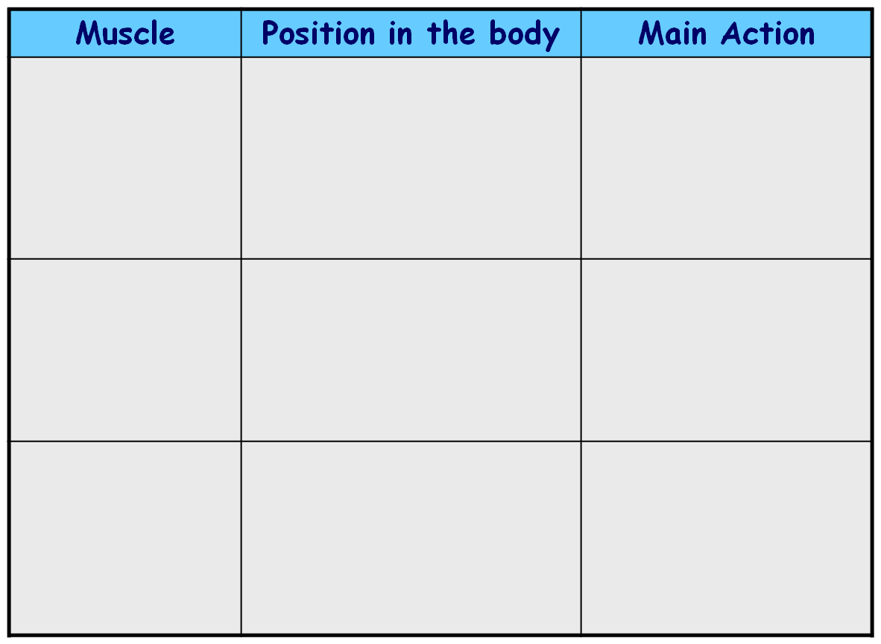

**Gluteals**

In the middle of the body at the back, forming the bottom.

At the top of each leg at the back.

At the bottom of each leg at the back. Also known as the calf muscles.

Extends the legs back at the hips.

Flexes the legs at the knees.



**Hamstrings**

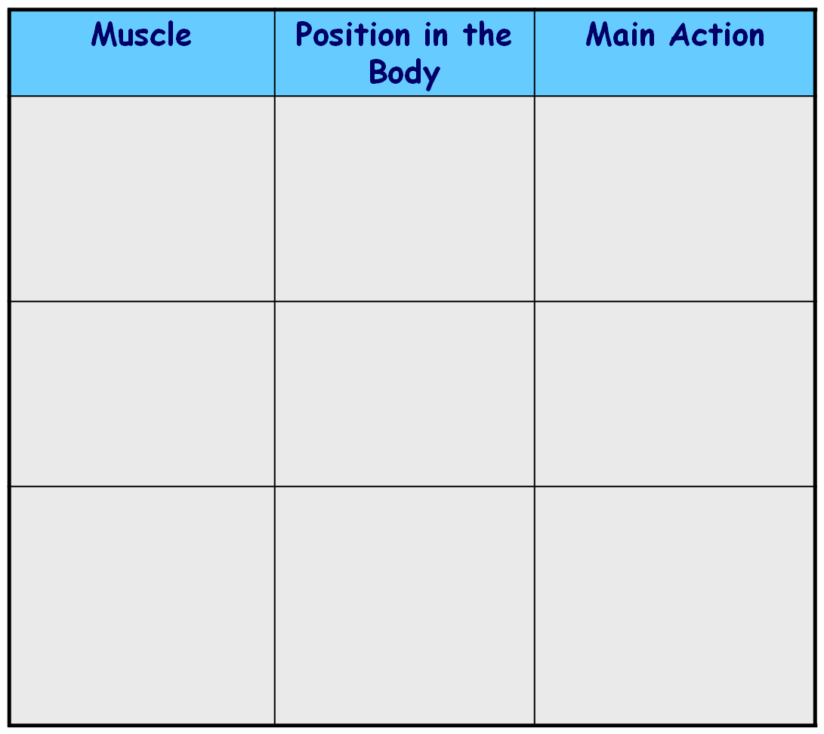

Extends the ankle so you can stand on your toes.

**Deltoids**

**Biceps**

**Quadriceps**



**Gastrocnemius**

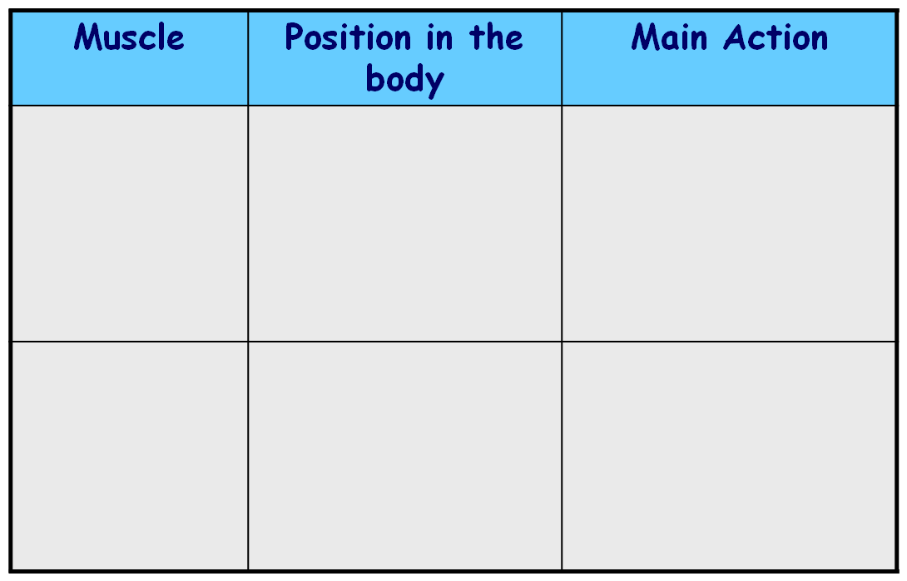

In the upper part of the body, covering the shoulders.

At the top of each arm at the front.

At the top of each leg at the front.

Raise the arms in all directions at the shoulders.

Flexes the arms at the elbow.

Extends the legs at the knees.

Raise the arms up, sideways and across the chest at the shoulders.

In the upper part of the chest at the front.

**Pectorals**

Flexion and rotation of the spine so you can bend forwards.

At the front of the body in the middle, just below the chest.

**Abdominals**

**1.2.4: A healthy active lifetsyle and your muscular system.**

**Exercising the muscular system.**

|  |  |
| --- | --- |
| The immediate effects of exercise on the muscular system. | |
| **Contract, lengthening and relaxing at an increased rate** | This is due to the muscles needing more fuel to function due to the body’s increased demand for oxygen and glycogen.  Extra waste products are created as muscles are working harder than normal. |
| **Lactic acid builds up** | If the demand for oxygen is too high and you are exercising anaerobically.   * This will lead to aching muscles and may cause muscle cramp. |

**How the muscles work.**

**Isotonic contractions**

Muscle contraction that results in limb movement.

* Muscle contraction that results in limb movement.
* Muscles work in pairs to cause movement: one contracts and another relaxes.
* E.g. When running, the hamstring contracts to lift the leg. The hamstring relaxes and quadriceps contracts to lower the leg.

**Isometric contractions**

Muscle contraction which results in increased tension but the length does not alter, for example when pressing against a stationary object.

* Muscle contraction where the muscle length does not change.
* E.g. In the plank position, at a rugby scrum, in a handstand.

|  |  |
| --- | --- |
| Long-term effects of participation in exercise and physical activity on the muscular system. | |
| **[http://c2470912.r12.cf0.rackcdn.com/wp-content/uploads/2012/07/John-Barban-Back-Pose-Adonis-Index-1024x913.jpg?9d7bd4](http://www.google.co.uk/url?sa=i&rct=j&q=back+muscles&source=images&cd=&cad=rja&docid=qIYyG-co98qLfM&tbnid=OR6cvMxSmQHx8M:&ved=0CAUQjRw&url=http://www.adonisindex.com/counter-contraction-the-adonis-row/&ei=WX8mUazRLKm-0QX_0YCICQ&bvm=bv.42661473,d.d2k&psig=AFQjCNFIOdYn5koOJ9QYPsrJUE5eg7X65g&ust=1361563849384047)Increase in muscle size - hypertrophy** | * Through applying progressive overload when training muscle fibres become damaged as they are pulled apart. * The body is able to rebuild the fibres over 48 hours making them stronger. * This causes hypertrophy and increased strength of muscles. * This will increase muscle strength and endurance and power (strength x speed). * This improves body posture, stronger ligaments (join bone to bone) and tendons (join muscle to bone) and may lower the risk of injury. |

|  |  |  |  |
| --- | --- | --- | --- |
| Potential injuries to the muscular system | | | |
| **Muscle atrophy** | * This occurs if strength training is stopped resulting in a loss of muscle mass and strength. * When sportspeople are injured they will experience muscle atrophy. | | |
| **Soft tissue injuries** | | | |
| **Tears, pulls and strains** | * These cause small muscle fibres to be torn from their attachment to a tendon. * During intense exercise muscle fibres contract and relax quickly which can cause the connective tissue and blood vessels inside them to be torn. * E.g. Footballers often pull their hamstrings due to the amount of time they are used in the game. | | RICE treatment is used for muscle strains.  First 24-48 hours are crucial during muscle injuries and rest should continue. |
| **Prevention of muscular injuries** | | | |
| **Warm up**  Raises the heart rate and warms the muscles. It should begin with gentle exercise followed by stretches. | | **Cool down**  Gradually bring heart rate back to normal and disperse any lactic acid. Gentle exercise followed **by stretches.** | |

**What is the skeletal system and what does it do?**

**1.2.5: A healthy active lifetsyle and your skeletal system.**

**The skeletal system.**

[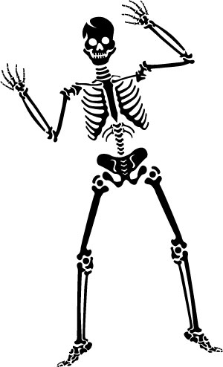](http://www.google.co.uk/url?sa=i&rct=j&q=skeleton&source=images&cd=&cad=rja&docid=KkSACK4Q8fT0qM&tbnid=YmR-iqhIoVsU_M:&ved=0CAUQjRw&url=http://www.humanrace.org.uk/super-skeletons/&ei=ZYQmUYbyNYeR0QXyqYCYBQ&bvm=bv.42661473,d.d2k&psig=AFQjCNFNwMmul0berNdWctUEXc_jaTmdQA&ust=1361565149876100)

**Movement**

*Bones meet to form joints. Tendons attach bones to muscles enabling**movements to occur.*

**Protection**

*Protects the vital organs from injury. E.g. the cranium protects the brain.*

**Support**

*Supports the body in a variety of positions giving the body shape. The skeleton acts as a framework for the body.*

**The structure of joints.**

* A joint is a place where two or more bones meet.
* The ends of the bones in a synovial joint are covered with a layer of thick cartilage – known as hyaline cartilage. This prevents friction, therefore pain and allows cushioning.
* Surrounding a joint is a tough capsule, this produces synovial fluid to lubricate the joint.

**1.2.5: A healthy active lifetsyle and your skeletal system.**

**Joints and movement.**

|  |  |  |  |  |
| --- | --- | --- | --- | --- |
| **Movement at joints.** | | | | |
| **Hinge joints** | | **Ball and socket joints** | | |
| The elbow joint | * Allows the arm to flex and extend. * Biceps cause flexion of the arm. * Triceps cause extension of the arm. * E.g. bicep curl, tricep dips | The shoulder joint | | * The ball-shaped head of the humerus fits into the socket of the shoulder. * Movements at the shoulder include flexion, extension, adduction, abduction and rotation as the head of the humerus rotates forwards/backwards. * E.g. bowling in cricket, swimming |
| The knee joint | * Allows the leg to flex and extend. * Hamstrings cause flexion of the leg. * Quadriceps cause extension of the leg. * The femur and tibia at the knee are held together by the **cruciate ligaments** – injuries often occur to these. * E.g. squats, leg press, jumping | The hip joint | |  |
| **Movement at joints.** | | | | |
| **Flexion** | if the angle of the joint is getting smaller. | | http://www.medtrng.com/flexionextension.gif | |
| **Extension** | if the angle of the joint is getting bigger. | |
| **Adduction** | if the movement is adding to the body. | | http://www.studydroid.com/imageCards/06/ed/card-6763582-back.jpg | |
| **Abduction** | if the movement is taking away from the body. | |
| **Rotation** | if the movement is around. | | http://cache2.artprintimages.com/lrg/38/3841/JYJYF00Z.jpg | |

**The effects of exercise and physical activity on bones.**

* Exercise helps bones to develop and become stronger.
* Exercise increases bone density. Bones become heavier and stronger.
* Ligaments and Tendons: become thicker and stronger. This increases flexibility and power in movement
* Bone continues to grow and strengthen until about age 18 therefore...
* young people should avoid excessive weight training / long distance training as this may cause bones to grow unevenly.

**The importance of weight-bearing exercise.**

* Bones become lighter with age and their density and strength are gradually reduced. This can occur naturally (bone is lost) resulting in a weak skeleton with bones breaking easily.
* Bones start to deteriorate at 35yrs of age.
* The condition is known as Osteoporosis.
* Exercise can delay the onset of Osteoporosis as can weight bearing exercises… running, tennis, aerobics, walking, and running.
* Yoga is a good weight-bearing exercise as it also improves balance, this reduces risk of falling.

**1.2.5: A healthy active lifetsyle and your skeletal system.**

**Exercise and the skeletal system.**

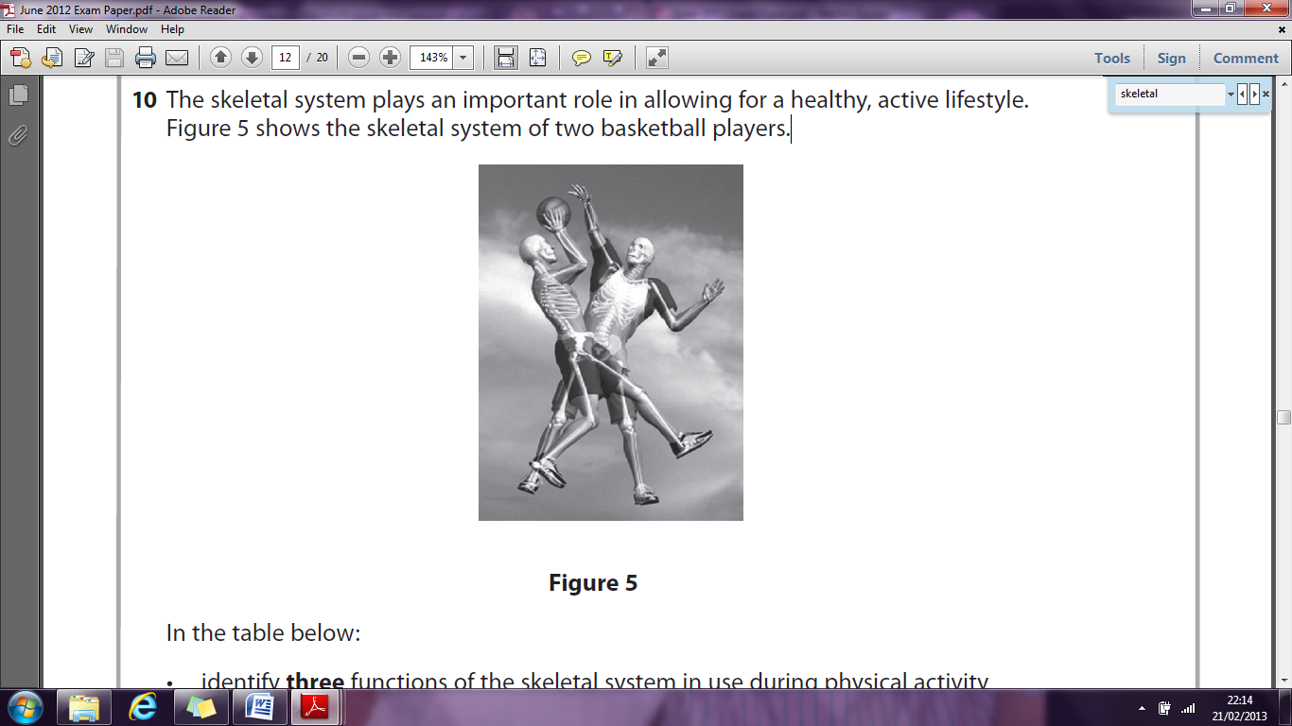

**Past exam question (June 2012)**

10. The skeletal system plays an important role in allowing for a healthy, active lifestyle.

Figure 5 shows the skeletal system of two basketball players.

In the table below:

* identify **three** functions of the skeletal system in use during physical activity **(3)**
* give **one** example of how each function is used during a game of basketball. **(3)**

|  |  |
| --- | --- |
| Function of the skeletal system during physical activty | Example of use during a basketball game |
|  |  |
|  |  |
|  |  |

**Past exam question (June 2012)**

10. The skeletal system plays an important role in allowing for a healthy, active lifestyle.

Figure 5 shows the skeletal system of two basketball players.

In the table below:

* identify **three** functions of the skeletal system in use during physical activity **(3)**
* give **one** example of how each function is used during a game of basketball. **(3)**

|  |  |
| --- | --- |
| Function of the skeletal system during physical activty | Example of use during a basketball game |
|  |  |
|  |  |
|  |  |

**Past exam question (June 2012)**

10. The skeletal system plays an important role in allowing for a healthy, active lifestyle.

Figure 5 shows the skeletal system of two basketball players.

In the table below:

* identify **three** functions of the skeletal system in use during physical activity **(3)**
* give **one** example of how each function is used during a game of basketball. **(3)**

|  |  |
| --- | --- |
| Function of the skeletal system during physical activty | Example of use during a basketball game |
|  |  |
|  |  |
|  |  |

**Past exam question (June 2012)**

10. The skeletal system plays an important role in allowing for a healthy, active lifestyle.

Figure 5 shows the skeletal system of two basketball players.

In the table below:

* identify **three** functions of the skeletal system in use during physical activity **(3)**
* give **one** example of how each function is used during a game of basketball. **(3)**

|  |  |
| --- | --- |
| Function of the skeletal system during physical activty | Example of use during a basketball game |
|  |  |
|  |  |
|  |  |

**10.** Accept movement **-** Any relevant court movement e.g. dribbling the ball towards the basket (1) *Do not accept example not linked to basketball e.g. running.* Accept Support **OR** shape **OR** structure (1) *Do not accept stability.* **Accept** Protection (1) Accept Prevents damage to (vital) organs during play if collision with others **OR** protects brain if ball strikes the head (1) *Do not accept example not linked to basketball.*

**10.** Accept movement **-** Any relevant court movement e.g. dribbling the ball towards the basket (1) *Do not accept example not linked to basketball e.g. running.* Accept Support **OR** shape **OR** structure (1) *Do not accept stability.* **Accept** Protection (1) Accept Prevents damage to (vital) organs during play if collision with others **OR** protects brain if ball strikes the head (1) *Do not accept example not linked to basketball.*

**1.2.5: A healthy active lifetsyle and your skeletal system.**

**Injuries to the skeletal system and the importance of diet.**

|  |  |  |  |  |
| --- | --- | --- | --- | --- |
| **Fractures** | | | | |
| * A fracture is a broken OR cracked bone! * Symptoms: Pain, inability to move area, swelling or bruising or deformity. * Sometimes you can hear the bone break! | | | | |
| **Closed fractures**  http://www.fractureadvice.com/sitebuildercontent/sitebuilderpictures/humerus.jpgThe skin over the break isn’t damaged. | **Compound fractures**  http://wendymichellesanders.com/wp-content/gallery/sfx/a-little-blurry-compound-fracture.jpgThe broken bone protrudes the skin (infection risk!) | | **Simple fracture**  http://worldoforthopedics.files.wordpress.com/2010/05/greenstick-fracture.jpegThe bone is only part broken – along one line. Common in children. Green stick fractures. | **Stress fracture**  Overuse injury, by increasing intensity of exercise or changing the playing surface (grass to road for running for example), and poor fitting footwear. Repetitive activities on hard surfaces increase the risk of stress fractures.  These fractures occur in weight bearing parts of the body (ie. The lower leg). Osteoporosis is linked with stress fractures and eating disorders. |
| **Joint injuries** | | | | |
| **Tennis and golfer’s elbow** | **Explanation:** overuse injury to the tendons at elbow joints. Often caused by incorrect size grip. Tennis elbow- pain outside of elbow. Golfers elbow – pain inside of elbow. | | | |
| **Signs and symptoms:** pain outside the elbow (tennis) or inside the elbow (golfers elbow). | | | |
| **Dislocations** | **Explanation:** when a bone is forced out of its normal position from a hard blow/fall causing the bones to displace. | | | |
| **Signs and symptoms:** swelling, deformity, pain, locked joint. | | | |
| **Sprains** | **Explanation:** a sprain is a damaged ligament (common example, a twisted ankle). Inverted or turned in ankles, pulling or tearing the ligament, stretching too far caused by twisting/ turning. | | | |
| **Torn cartilage** | **Explanation:** cartilage is a firm elastic substance found at the end of the bones of a synovial joint. Pivoting can cause a tear in the knee. | | | |
| **Signs and symptoms:** pain at the site, knee likely to be bent. | | | |
| **Treatment for injuries** | | | | |
| **R.I.C.E**  **Limits swelling and provides pain relief in minor injuries.** | | | | |
| **Rest** | | STOP! Playing or training. | | |
| **Ice** | | Reduces blood flow to the area, limits swelling and provides pain relief. | | |
| **Compression** | | Apply pressure to the ice pack. Limits swelling. | | |
| **Elevation** | | Raise the injury and keep it raised. Reduces swelling. | | |
| **Diet and the skeletal system.** | | | | |
| **Diet is essential for a strong, healthy skeletal system.** | | | | |
| Balanced diet and calcium rich = increased growth and density | | | | |
| Vitamin D – essential to growth and maintenance of healthy bones and aids the absorption of calcium. | | | | |
| Smoking and too much alcohol are TOXIC to bones! | | | | |