MAGNUS C of E ACADEMY
A Christmas Carol
English Literature. Paper 2: Revision and exam Q booklet

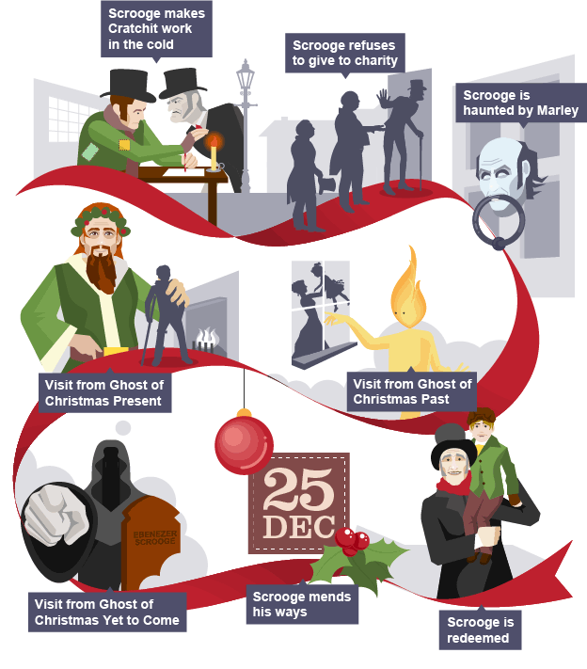

A Christmas Carol: a timeline of major plot events

Ebenezer Scrooge
- Miserable
- Tight-fisted
- Redeemed by the end

Scrooge is the main character of Dickens' novella and is first presented as a miserly, unpleasant man. He rejects all offerings of Christmas cheer and celebration as 'Humbug!'
On Christmas Eve he is visited by the ghost of his old business partner, Jacob Marley, who warns that he will be visited by three ghosts. Each of the ghosts shows him a scene that strikes fear and regret into his heart and eventually he softens.
By the end of the story, Scrooge is a changed man, sharing his wealth and generosity with everyone.
 | How is Scrooge like this? | Evidence | Analysis
Cold-hearted | According to Dickens's description, Scrooge is cold through and through. | No warmth could warm, no wintry weather chill him. | Dickens uses pathetic fallacy to represent Scrooge's nature. The weather is a metaphor for Scrooge's behaviour as he cannot be made either warmer or colder by it.
Miserly | Scrooge is stingy with his money and will not even allow his clerk Bob Cratchit to have a decent fire to warm him on Christmas Eve. | ...as the clerk came in with the shovel, the master predicted that it would be necessary for them to part. | The indirect speech shows that Scrooge is threatening and in charge. He will not give permission for Cratchit to take more coal.
Ill-mannered | His nephew visits to wish him a 'Merry Christmas' and Scrooge is rude to him in response. | "Every idiot who goes about with 'Merry Christmas' on his lips, should be boiled with his own pudding, and buried with a stake of holly through his heart." | Scrooge's response is comical, but unpleasant. He cannot accept the generosity that is offered him and instead turns images of Christmas into images of violence.
Self-deluded | When he sees Marley's ghost, Scrooge tries to deny its existence by attributing the vision to something he has eaten. | "You may be an undigested bit of beef, a blot of mustard, a crumb of cheese..." | Although Scrooge is afraid of the ghost, he tries to maintain his authority even over his own senses.

Bob Cratchit
- Humble
- Hardworking
- Family man

Bob Cratchit is Scrooge's clerk and works in unpleasant conditions without complaint. He obeys Scrooge's rules and is timid about asking to go home to his family early on Christmas Eve.
When the Ghost of Christmas Present takes Scrooge to visit the Cratchits on Christmas Day, he sees Bob Cratchit carrying his sickly son Tiny Tim, and later raising a toast to Scrooge for providing the feast.
The Ghost of Christmas Yet to Come shows the Cratchits in a future where Tiny Tim has died and here we see how sensitive Bob Cratchit is. His love for his son is shown through his grief.
In the end, when Scrooge changes his ways for the better, Bob Cratchit is delighted. He welcomes Scrooge's new-found generosity and friendship.

 | How is Cratchit like this? | Evidence | Analysis
Obedient | Bob takes orders from his bad-tempered boss, Ebenezer Scrooge without complaining. | [he] tried to warm himself at the candle | His efforts to warm himself at the candle are pitiful. He would prefer to do this than challenge Scrooge.
Generous | He proposes a toast to Scrooge even on Christmas Day. | "I'll give you Mr. Scrooge, the Founder of the Feast!" | Scrooge is too miserly to offer his clerk a decent wage, but Cratchit is generous enough to be grateful to his boss.
Sensitive | He cries openly for his son when he is ‘dead’. | "My little, little child!" cried Bob. "My little child!" | The repetition of 'little' adds to the sad effect of Bob's cry. We feel sympathy for him at this point.
Fearful | He is afraid of Scrooge's reaction when he arrives late to work after Christmas Day. | "It's only once a year, sir," pleaded Bob, appearing from the Tank. | Bob 'pleaded' which shows he is worried about being punished by Scrooge.

Fred
- Cheerful
- Generous
- Kind-hearted

 | How is Fred like this? | Evidence | Analysis
Positive | Even when Scrooge puts down all his talk of Christmas festivities, Fred persists with his good cheer. | "I'll keep my Christmas humour to the last. So A Merry Christmas, uncle!" | We learn about Fred's positive nature from his dialogue. Everything he says focuses on the positive aspects of Christmas.
Persistent | Fred refuses to let Scrooge's miserly attitude dampen his sprits. | "I mean to give him the same chance every year, whether he likes it or not, for I pity him." | He shows his care for his uncle by pledging to continue visiting Scrooge regardless. His concern is revealed by his persistence and pity.
Enthusiastic | When Scrooge finally turns up for Christmas dinner, Fred welcomes him in. | "Let him in! It is a mercy he didn't shake his arm off." | Fred's enthusiasm is evident in his hearty welcome, shaking his uncle's hand with force.

The Ghost of Christmas Past
- Young and old
- Commanding
- Streaming with light

The Ghost of Christmas Past is the first spirit to visit Scrooge after the ghost of Marley. It arrives as the clock chimes one. It is an ephemeral spirit that appears to be both old and young at the same time with light streaming from the top of its head.
It takes Scrooge to scenes from his own past, showing him visions of his own childhood, of his young adulthood and of happier times. The final scene he presents is one that Scrooge cannot bear to witness: his lost love, Belle, with her family.
Scrooge turns on the ghost and demands to be shown no more. He attempts to extinguish the ghost's light with its own cap, wrestling it to the ground. However, the light that shines from the ghost cannot be put out.

 | How is the Ghost like this? | Evidence | Analysis
Ephemeral | This ghost is shifting in appearance, seeming to be there and not be there at the same time. | ...what was light one instant, at another time was dark, so the figure itself fluctuated in its distinctness. | The ghost is surreal and strange. It flickers like a candle and seems to reflect the fact that Scrooge's past behaviour can be redeemed.
Gentle | The ghost is not solid and is also calm and gentle in the way it communicates with Scrooge. | The Spirit gazed upon him mildly. Its gentle touch, though it had been light and instantaneous, appeared still present to the old man's sense of feeling. | The words 'mildly' and 'gentle' give us the overall sense that the ghost is well-meaning.
Quiet | The ghost does not speak much, but answers Scrooge's questions with brief replies. | "Your welfare!" said the Ghost. | When Scrooge asks the ghost what its business is that evening, the response is short and to the point. This ghost does not waste words!
Firm | Although the spirit is ephemeral and gentle, it is also commanding. | It put out its strong hand as it spoke, and clasped him gently by the arm. "Rise! and walk with me!" | The imperatives (verbs in command form) 'Rise' and 'walk' show that the ghost is to be obeyed. It has control here.

The Ghost of Christmas Present
- Jolly
- Welcoming
- Prophetic

The Ghost of Christmas Present is a huge and vibrant character who appears as the bell, once again, strikes one. It appears in Scrooge's room, surrounded by a feast. The generous nature of this ghost is reflected in the abundant vision of food.
Scrooge is more humble in the presence of this second spirit and is willing to learn any lessons the ghost will show.
It shows Scrooge visions of the world on Christmas Day, including heart-warming scenes of celebration at the homes of Bob Cratchit and Scrooge's nephew, Fred.
Before it leaves Scrooge, the Ghost shows him two 'yellow, meagre' children who are hiding under its cloak. These are called Ignorance and Want and are a warning to Scrooge to change his ways.

 | How is the Ghost like this? | Evidence | Analysis
Jolly | Dickens describes the ghost as open and cheerful - in actions and appearance. | Its dark brown curls were long and free; free as its genial face, its sparkling eye, its open hand, its cheery voice, its unconstrained demeanour, and its joyful air. | The adjectives that Dickens uses are positive and present a solid big and 'joyful' character, in contrast to the indistinct spirit of Christmas Past.
Welcoming | The Ghost invites Scrooge to join him in a welcoming manner. | "Come in!" exclaimed the Ghost. "Come in! and know me better, man!" | The word 'exclaimed' makes the Ghost seem excited to see Scrooge. His invitation to 'know me better' is generous and open-hearted.
Honest | When Scrooge asks whether Tiny Tim will live, the Ghost answers with the words Scrooge had previously spoken to the portly gentlemen who were collecting for charity. | "If he be like to die, he had better do it, and decrease the surplus population." | The Ghost of Christmas Present uses Scrooge's own words against him. In his honest response, that Tiny Tim is likely to die, he holds a mirror up to Scrooge and his behaviour.
Prophetic | The Ghost predicts that Mankind, Scrooge included, will suffer unless the lessons of generosity and tolerance are learned. | "Most of all beware this boy, for on his brow I see that written which is Doom, unless the writing be erased." | He presents two children called 'Ignorance' and 'Want' hiding under his cloak. He warns that 'Doom' awaits Scrooge unless a change is made.

The Ghost of Christmas Yet to Come
- Silent
- Dark
- Ominous

The final Ghost is frightening and eerie. It doesn't say a word to Scrooge, but glides along and points out scenes to him.
The spirit first shows Scrooge a funeral scene, with businessmen wondering about the money that the dead man has left. The Ghost then takes him through dark alleyways to a scene of three people picking through the belongings of the deceased. Scrooge recognises that his own death could be met this way.
Next, the Ghost takes him to the Cratchit household where Scrooge is upset to learn that Tiny Tim has died.
Finally, the Ghost shows him a tombstone engraved with the name: Ebenezer Scrooge. Clutching at the spirit's robes, Scrooge pledges to change his ways if he can avoid this solitary death. The Ghost disappears and leaves Scrooge clutching at his bed curtains.

 | How is The Ghost like this? | Evidence | Analysis
Silent | This last ghost does not speak at all. It is the most haunting in appearance. | ...a solemn Phantom, draped and hooded, coming, like a mist along the ground, towards him. | Dickens shows a 'solemn' and spooky spirit in the Ghost of Christmas Yet to Come.
Frightening | The ghost fills Scrooge with terror. | Scrooge feared the silent shape so much that his legs trembled beneath him, and he found that he could hardly stand when he prepared to follow it. | The presence of this ghost makes Scrooge afraid. His trembling legs and inability to stand firm show how he is worried about the future that the ghost will show him.
Demanding | The ghost points wherever he wants Scrooge to look and does not move until he obeyed. | Still the Ghost pointed with an unmoved finger to the head. | The Ghost of Christmas Yet to Come silently demands that Scrooge pays attention. The spirit's silence is unrelenting.

Tiny Tim
- Kind
- Disabled
- Thoughtful

Tiny Tim is one of Bob Cratchit's sons. He walks with a crutch and has 'his limbs supported by an iron frame'. Despite his physical difficulties, he is a positive and generous child. He thinks of others and is well-loved by his family.
Scrooge is affected by the child and when he is shown the Cratchit family Christmas by the Ghost of Christmas Present, he worries whether Tiny Tim will live. The Ghost of Christmas Yet to Come shows a possible future in which Scrooge's fears are realised and Tiny Tim has died.
At the end of the novella, after Scrooge changes his character, we learn that he becomes like a second father to Tiny Tim.

 | How is Tiny Tim like this? | Evidence | Analysis
Kind | After Bob Cratchit raises a toast at the Christmas dinner table, Tiny Tim echoes the toast and includes everyone. | "God bless us every one!" | We learn that Tiny Tim is kind and able to offer an equal love to all mankind.
Thoughtful | Tiny Tim rises above his own suffering and hopes that people who see him will think of Jesus. | He hoped the people saw him in the church, because he was a cripple, and it might be pleasant to them to remember upon Christmas Day, who made lame beggars walk, and blind men see. | Dickens suggests that the child is exceptionally thoughtful for his age. This highlights how ungenerous Scrooge, an adult, can be.
Patient | In the scene that the Ghost of Christmas Yet to Come shows of the Cratchits, Bob remembers his son as a patient child. | ...we recollect how patient and how mild he was. | Tiny Tim is remembered fondly by his family for his good qualities.

GCSE English Literature [Edexcel]
Answering extract questions (Macbeth/A Christmas Carol)
The mark scheme assesses you for your ability to comment on the following:
- Language: individual words/techniques
- Form: the type of text/narrative voice
- Structure: who speaks the most/is it dialogue or narration?
- Audience/reader
How to structure your response:
Introduction | Write a 1-2 sentence introduction providing an overview of the extract
Contents | Write 3-4 APE paragraphs
APE Paragraphs
Answer | - State your answer  - Recycle words from the question
Provide evidence | - Must be a quotation from the extract
Extend | - Unpick language – the more you unpick the better!  The use of the word “….” emphasises……  The use of the adjective/verb/noun/adverb “…” creates the ideas…..  Through the use of the simile [or other technique] “.....”, the writer emphasises….  - Comment on how the writer wants their audience/reader to react to this.  The writer intended to make their audience…..  This would [emotion e.g. shock] the audience because…..

Sample question

Question 4 – A Christmas Carol
4 (a) Explore how Dickens presents Scrooge’s character in this extract.
Give examples from the extract to support your ideas.

(20)

(b) In this extract, poverty is discussed.

Explain how Dickens portrays poverty elsewhere in the novel.
In your answer you must consider:
• what poverty is shown
• how poverty affects those involved.
(20)
(Total for Question 4 = 40 marks)

